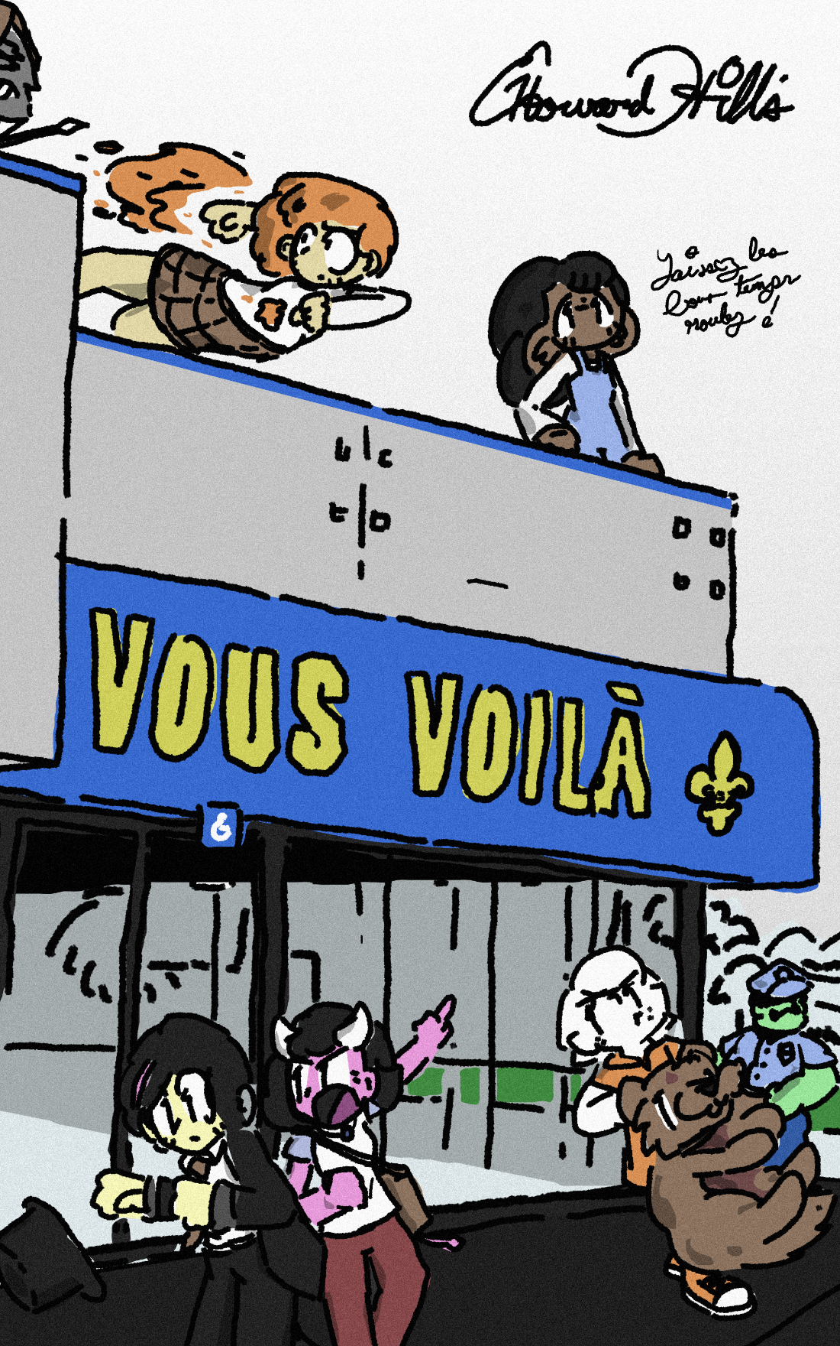
Vous Voilà written and illustrated
by E. Howard Hill

All Rights Reserved.

Thanks to my friends who helped me name characters, inspired situations, and supported me through wanting to see this project come through in one way or another. I know I couldn’t make a full cartoon series, but I hope this is the next best thing – enjoy!

Thanks to the fine folks at r/cajunfrench for checking and helping me with my Louisiana French! Merci de votre aide!
Contents
Part One 5
Tape 1 6
Tape 2 10
Tape 3 17
Maple’s Rapidly Dwindling Options 19
Letter to Aaron 25
…Potions Class 27
Part Two 33
They Actually Do It 34
Into the Woods 38
The Martians Leave a Note 40
Into the Woods (cont’d,) 42
Felix and Coralie’s last dinner 46
Now they half to escape 49
Nim sees suspicious activity 55
Old lady purse thieves 60
After the tiny bus naps 65
Meanwhile with Nim… 69
Mama Mia (here we go again) 72
Coralie’s Dad 78
An Outdoor Shopping Centre 81
Next stop, license plates 85
Interrogation No. 1 (Maybe) 87
Masters of Disguise 90
Part Three 95
Oh no, it’s them again 96
A Little Update 100
They fall off the truck 102
They’re not eating anymore 107
That family member everyone has 111
Deciding on a good dinner 114
Sleep is for the weak 120
It’s not as cool as you’d think 127
Brief break in the narrative 131
A Slight Change of Pace 134
Part Four 140
And back to Felix for a bit! 141
Portal to the Abyss 143
Speaking of Magicians… 147
La Poivrette 151
Return of the Weird Uncle 154

Part One
or, “The Impulsive Decisions of Scared and Confused Individuals Can Yield Unusual Results.”

Tape 1
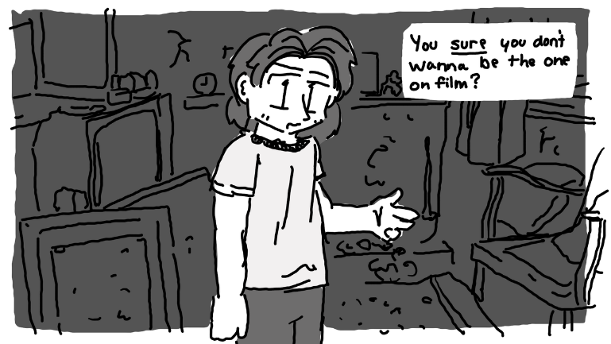
1992/06/11

"No! You got me the camera, you're in front."
Aaron sighed. "Alright. So what do you want me to say?"
"I dunno. Pretend like we're shooting a documentary or something."
He coughed, looking around the room to find some shred of something - anything to talk about. The walls were cracked and the wallpaper was spoiled. Way too much paper and trash was spread across the rotting carpet. It smelled, but a breeze coming in through a hole in the wall made it tolerable.
"I mean, I guess every place has a story, even random abandoned houses... I don't know, is that what you want me to talk about?"
Maple sighed. "Make something up!"
"Bon." He cleared his throat. "Hundreds of years ago, fairies crafted this castle out of what little material they had available. When settlers moved to the Laurentides, they saw this structure and thought... Man. That's sick. Let's take that exact design and make millions of em all across the country. And so they did, and before long, it seemed like everyone lived a cheap recreation of the fairies' castles. That's when the fairies got mad, and after the legal system got established, they tried to make a lawsuit out of it, but it fell through because you can't copyright good design."
"Shame."
"Yes, it was a real shame."
The two heard a car outside pull up.
"Just like the fact that we have to go."
"But-"
"Cops..!" he hissed. "Quick out the back door!"
Right before Maple turned off the camera, or at least, right before she thought she turned off the camera, she pointed it at the floor, giggling a bit under her breath. "Best birthday ever."
The sound of a slamming door could be heard from the other room.
"HEY!" shouted a man in thick Creole French, "WHAT ARE YA'LL DOING ON MY PROPERTY?"
Maple sucked in air. So it wasn't the police. It was the property owner. Oh boy.
She dumped the camera into her backpack, slipping her free arm through one of the satchels to keep it completely stable. The sound of the man was getting louder, as was the sound of the two siblings. Tape watchers wouldn't have known what was going on, besides from their quiet attempts to escape. At least, until there was a gunshot. Maple and Aaron stopped breathing for a moment.
"I got this," whispered Maple, taking off her backpack.
"No, you- WHAT-" hissed Aaron.
"HEY!" shouted Maple, "STOP SHOOTING AT US OR I'LL BURN IT DOWN."
Footsteps. "Yer do what know?"
The sound of a flame started.
The man panicked and raised his gun, but Maple lunged faster. The sounds of dripping metal and a confused old man filled the space.
"Yer... Yer twisted my gun barrel."
"I did."
"I... I think I'm gonna go home now."
"Wise choice."
He left the room.
Maple dashed over to her backpack, lifting out the camera and pointing it straight at her face. Her fiery orange hair glimmered nearly as much as her giddy grin. The shot wasn't in focus at all, but it didn't need to be. "I just made a gun pretzel," she squeaked.
"MAPLE!" hissed Aaron, "That is not swell! Dude! What the heck?"
"LOOK!" she said, pointing the camera at the ground were some of the steel had dripped off and onto the floor, "DO YOU SEE THAT?"
He sighed. "This is going to catch up to you, you know."
"Eh, maybe."
"Can we leave the property now?"
"Maybe he'll let us live here if I threaten to break more of his guns."
"No!" Maple turned the camera to her brother to catch him crossing his arms. "We're not going to hold him captive on his own property."
"So we're sleeping in the car again?"
"Yes!"
"Why?"
"Because we own it!"
Her frown could be heard in her voice. "That's a stupid reason. Besides, it's my birthday. I'm a teenager now, I can do whatever I want."
"Society doesn't care!"
"But you care, and you're not society."
He grumbled.
"Hey. Louder for the camera."
He continued mumbling, but it was now possible to understand what he was saying. "If you're staying here, I'm staying here too, but only for today, am I clear?"
The camera made a wide zoom up to his face.
"Focusing in on... the best big brother on the planet."
"Shut up."
"You shut up!" And with that, the camera turned off.

Tape 2
1993/07/01

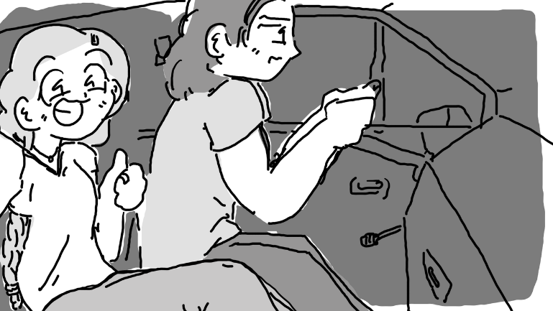
"Bon, I'm filming again."

Aaron had his hands on the wheels, his full attention on the road. "Why now?"
"Why not now?"
"Do you want me to film you when you get behind the wheel?"
"Uh.. What do you think?"
He sighed. "Fair enough. Now, I don't have too much gas left, so we won't do too much, alright?
Maple nodded, and it shook the camera a bit. "But didn't you get that new job so you can afford more gas?"
"No, I got an interview, not a job. It's not a guarantee."
"Bet it'd be a little easier if you, y'know, had help."
"Maple, we've talked about this."
She groaned. "When are we finally getting there?"
"We're there." He put the car into neutral. "Porkly Borkly's parking lot is probably the best possible place to get these techniques down. Now, do you need me to remind you of anything, or do you think you want to just get behind the wheel and take it for a spin?"
"I'll just try it out. I think I know enough."
She dumped the camcorder on the dashboard and popped off her seatbelt, nearly sprinting over to the driver's side, already there by the time Aaron was just stepping out. In an instant, she was behind the wheel, gripping the wheel with a fierce intensity. It felt good to be fourteen. It felt good to be behind the wheel of her what had been her home for so long. She felt butterflies in her stomach that nearly made her nauseous - definitely a bit queasy. Her hands couldn't help but shake. She was ready, so, so ready.
"Alright, so the first thing you want to do is-"
"Aaron, chill, give me a moment, bon?"
"Right," he sighed. "Of course. I-... Right. Go ahead."
"Hey, chill. You're stressing me out."
"Got it. Sorry."
She sighed, smiling. Then, she adjusted her seat a bit and tested out the clutch. She popped the car into first gear and pushed down on the accelerator, bursting into a fit of nervous giggles.
"You're scaring me."
"I'm fine with that,'" she chirped, slowly accelerating to ten or so kilometers per hour.
"Swell, now we're going to try the- Maple!"
"What?"
"Lightly on the break! That nearly launched me through the window!"
"You've done it that hard before!"
He sighed. "Only in emergencies, you hear? Look, you want to do it slower than that or you'll hurt the car."
"I thought you said that acceleration was slow, breaking was fast."
"Not that fast."
"Right, right, whatever. I'm going to try second gear, now."
"Maple, there's a car coming up on your left."
"Yeah?"
"Maple!"
"I'm braking! I'm braking! Gosh!"
The car jolted a bit. Maple's face went completely flushed, and Aaron sort of stared ahead, dumbfounded. The car stopped. There were no noises of anything going wrong in the engine, or any frustrated noises from the two, just silence. Dead, unnatural silence. Even the radio, which had been going quietly, stopped, though the hum of the engine kept the camera shaking.
An orc man walked up to the driver's side door, knocking angrily on the glass.
"I mean," defended Maple, "I was braking lighter that time."
"...I said emergencies were the exception."
"How was I supposed to know that was an emergency?"
Knock knock knock. "HEY!"
"You know... I could just drive out of here really fast."
Aaron sighed. "No. Roll down the window."
"I think I will drive away really fast."
"No!!"
"If I roll down and talk to the guy, he's just going to insult me and nothing's going to get resolved."
"That doesn't mean that you need to face your problems every once in a while."
Maple rolled down the window slightly.
"YOU DIRTY PIECE OF-"
She rolled it back up. "Your point?"
"Stay here." He unbuckled his seat belt. "I'll talk to- Hey, are you-?"
Maple grinned, as the world outside the car slowly began to move backwards.
"Maple, stop the car. I told you not to-"
"You told me not to drive away really fast when, in fact, I am driving away really slow."
"No! I told you-"
"What? I can't hear you, I'm too busy driving away from the conflict."
WHAM!
"MAPLE!! Dag nabbit- he's attacking the car!!"
Coolily and in an instant, she set the gear to reverse. and floored it. Aaron gripped his seat, muttering something under his breath.
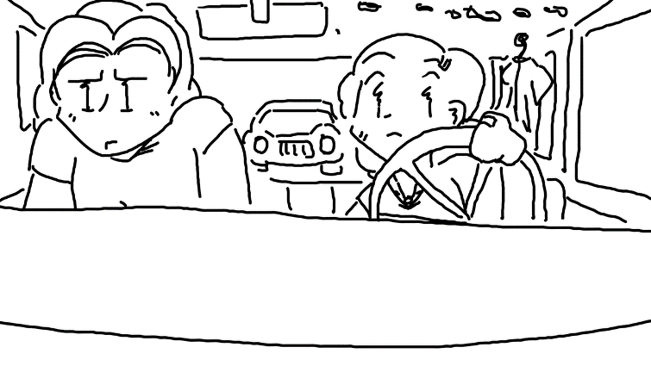
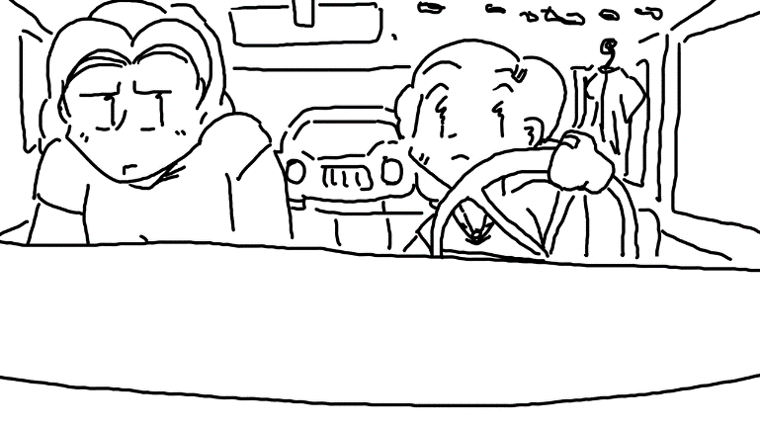
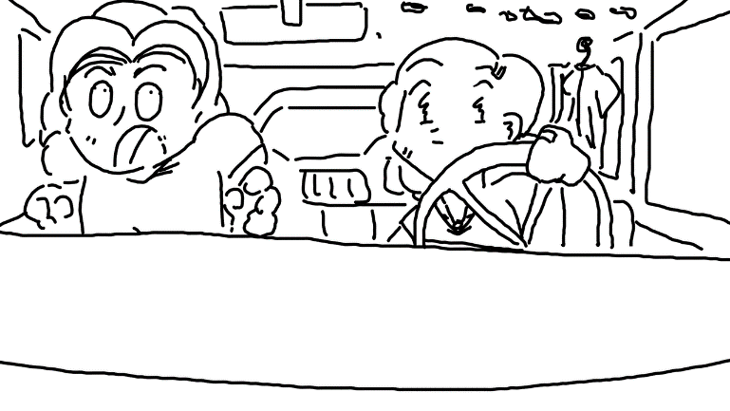
WHAM!
"You're going to be the death of me..." whispered Aaron.
"W-Wait, I can fix this!" she squeaked, frantically trying to remember what to do. She popped the clutched, changed gears, and started bolting ahead in third gear. Aaron gripped the seat even harder as she sat right on top of the speed limit, merging into traffic and speeding down the highway without as much as a second thought. Or at least, no more thinking than she was doing - she was nearly hyperventilating, gripping the wheel so hard that it wouldn't have been much of a surprise if it just came completely off.
"MAPLE!"
"WHAT?"
"PULL OVER!"
Despite her accidents, she seemed to have a good understanding of the driver's education she had taken. She pulled off to the side in front of a gas station, hands still shaking.
"Maple."
"...I'm sorry, I-"
"..."
She sniffed, tearing up. "Alright, I made a dumb mistake."
Aaron crossed his arms, letting out his breath in short bursts.
"...You, um... Y-You do have to admit, it was pretty fun."
He smiled. "It was. Just a bit."
"And we got the whole thing on video."
"You understand that if those people ever see us on the road again, we're dead, right?"
She fidgeted awkwardly. "M-hmm."
They were both silent for a few seconds.
"I'm driving now."
"Right, right, I'll get out."
"And we're doing this exercise out of city limits next time."
"Of course."
"Now to see how much damage we got."
"Hey- Can... Can we do that after we get back to the apartment?"
"Sure, whatever. Are you gonna shut off the camera?"
"Yeah, right, good idea." She reached for the camcorder and shut it off.

Tape 3
1997/07/13

Aaron Tremblay was by himself in the living room / kitchen, alone with the camera. There wasn't a lot of wiggle room, but he made do with enough room to stand. He couldn't quite see that it wasn't eye level, and that he was off-focus to the left - his nerves made it clear that something else was on his mind by the way he kept nervously clenching and unclenching his fists.
"Hey, Maple. Uh... So, you know how you kept telling me that I could use your camera and I kept procrastinating? Well, I'm done procrastinating, hehe.. I just wanted to record you a short video while I you were out of the house, which, you are a lot, and I don't blame you, your boyfriend's definitely got a better apartment than I do. And I really don't have much more to give you on your way out that I haven't already, but I thought I'd finally take care of that video you've been wanting me to do, so, uh.. here it goes."
"I know you're nervous about college. I know high school wasn't really your thing and you feel like it's stupid. I.. know I've already tried explaining that these scholarships aren't very common, there really aren't a lot of wood elves in this parish, but you know what? You're bigger than this parish. I've known it since we were kids. It's why I keep pushing you so hard. And you're going to be on your own, an adult, doing whatever you want, and I'm really freaking excited. You've got the potential to be the best sorceress in South Louisiana. I mean it. I'm not exaggerated. You've done so many freaking cool things. I'm going to miss you a lot. But it's worth it when I think of all the stuff you'll do. The cool friends you'll make. Charlottesville Magic University is a big deal, Maple. Please don't forget about me when you're rich and famous, though."
"That's all I wanted to say. I don't want to take up all your videotape. And I know you might not ever see this. But you know what? ...I think you'll see it at the right time. Maple? I'm proud of you, and I love you no matter what, you know that, right?"

Maple’s Rapidly Dwindling Options
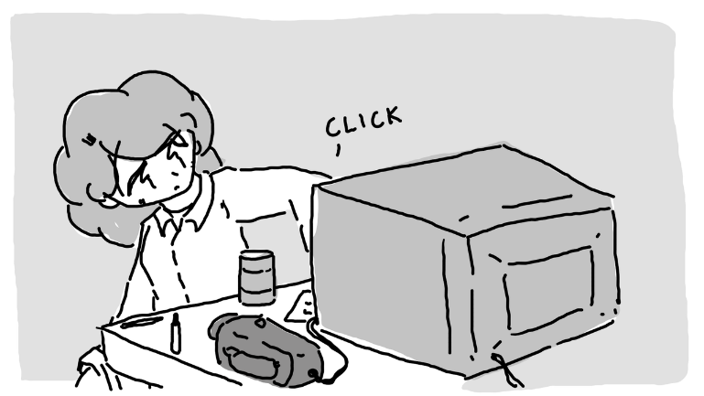
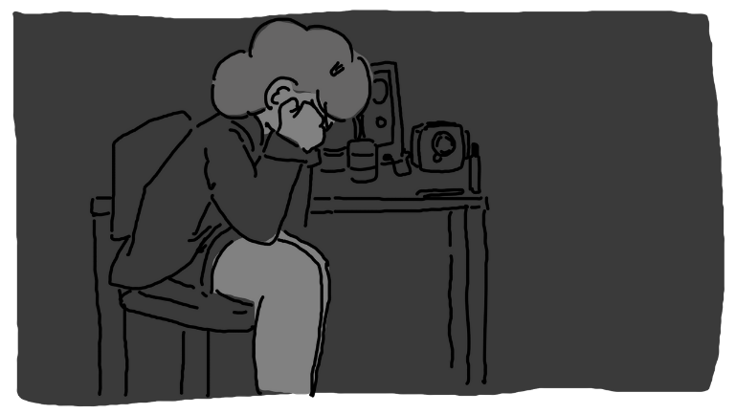

Of course she had taken her camcorder to college, and about a month and a half into it, she needed it. Yeah, Aaron knew exactly how to encourage her while simultaneously make her feel like a terrible person. Not that he knew he was doing it, of course. But he definitely was.
After checking to make sure her roommate was gone, she pulled a cigarette out of a drawer and snuck over to the window. She snapped, and a little fire on the tip of her finger lighting the tip. Every puff dulled her tensions, but she couldn't help but think back to all the times Aaron told her to stop smoking - it was just too expensive.
She considered the off-campus floor fais do-do that night - music, dancing, social interaction. She felt lonely without a boyfriend and was somewhat hopeful that she could find someone there, anyone to talk to, really. There was a paper due tomorrow that she didn't plan on doing. Potions class. She simply could not fathom why potions class could possibly in any way be relevant to a sorceress majoring in Warlocking.
"Hey, Maple!"
"ENO-" she squeaked, tossing the cigarette out the window, "You're... You're back early."
Maple sighed. Her roommate was Enoki Ramirez, the most innocent girl on campus, who always dressed like she was nine years old and wore a consistently naive facial expression. To Maple, she was like a gas station beverage that was sweet enough to keep a child happy but sour enough to make any adult consumers wish they could vomit.
She sniffed the air like a puppy, her face mellow and unphased. "It smells spicy."
"I was, um.. I.."
Enoki began to wave her arms around...
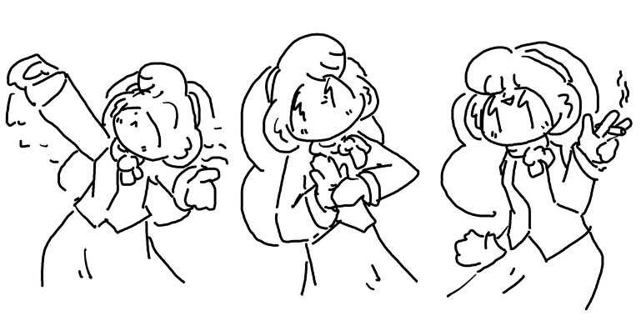

...producing a cigarette from one of her thick, velvet sleeves. It was even still burning. "Is this your card?"
Maple stomped over and stole it from her. "How did you do that? I thought you hadn't taken conjuration yet."
She giggled. "I'm not supposed to tell you how I do my tricks, silly!"
"Jerk."
"Dumb-face." She walked over to her bed, sitting down on it. "So what's wrong?"
Maple began to puff on the cigarette that Enoki had produced from her sleeve. "You wouldn't understand."
"I might a little bit."
She sighed. "I don't know what to do."
"So... I was thinking..."
Maple feigned ignoring her and leaned against a shelf.
"How about we run away from the school?"
She scrunched her eyes a bit. "You worded that as if it's not a figure of speech."
"You know, just up and leave. Pack bags. See where the road takes us."
"Enoki, are you out of your mind?"
"I don't think so."
Maple took out her cigarette and began to examine it. "You see nothing wrong with two teenage girls, barely adults, in the middle of the woods for miles, with no money and no discernable end goal? Doesn't that sound like a really, really bad idea to you?"
"No."
"And, uh- Isn't your dad Amihan Ramirez? The Amihan Ramirez?"
"Yeah."
"And you don't see any problems with this?"
She beamed ear to ear. "None at all."
"I guess I've got no reason to keep from dreaming. Now, uh.. I'm going to start working on my paper for tomorrow, don't bother me." She got up and walked over to a desk on the other side of the room, clicking on a light and sitting down.
"Didn't you wanna go to that fais tonight?"
Maple looked over her shoulder. "Not this time. Don't bother me."
"I won't make a peep."
"Good." With that, she pulled out a sheet of paper and began to brainstorm a topic. "Hey, uh.. You don't happen to have any extra copies of reference material from when you took potions, do you?"
No response.
Maple looked over, and Enoki was sitting in her bed. She had opened her backpack and pulled out a package of sliced mushrooms, eating them straight out of the bag. Maple blinked a few times, confused.
"You heard me, right?"
Enoki nodded.
"Well, do you?"
She nodded again.
Maple groaned. "You can talk when I'm talking to you."
Enoki made no clear gesture to indicate whether or not she was listening.
When she finally sat down to write the paper, she tried to remember anything from class. Anything at all. Not that she had been paying attention, of course - it was in the morning, and more often than not, she was hungover, and her head hurt far too much to pay attention.
But having Enoki's notes from when she took the class were nice. Maybe she could even steal the same topic and just change a few of the notes. She wondered if any of the professors might catch on, with this being the work of Enoki Ramirez, of course. She hoped not.
She really didn't want to start writing this paper, and as she did her best to think of literally anything else, she wondered if maybe she could make a tape to send back to Aaron. If he had a video player, of course. He could always rent one from the Grandsuccès right down the road from the apartment if he needed to, of course.
Maybe a letter would be better, anyway. The paper was already in front of her, after all.

Letter to Aaron

Dear Aaron, ça va?

Hey, so, I suck at writing letters. I'm sorry I haven't called in a few weeks - the phone is kind of expensive and everyone on my floor likes using it. But I'm going to try and see if I can send a letter anyway.
School's been great, but I really, really don't think I fit in here. I watched the tape you made for me. I really wanted to cry. I didn't realize how much I missed you until I got here. I haven't been doing too great, but I'm going to do better. I promise.
So there's this crazy thing - I'm still roommates with Enoki Ramirez, and I still can't figure out how I feel about her. She gets under my skin sometimes, but, well.. then she pulls a cigarette out of her velvet coat sleeve. A lit cigarette. And it was just there without any smoke. She calls these things magic tricks, and I know she's just a human like you, but sometimes I wonder. Other than my fire power, she's sort of the only thing I have going to brag about at fais do-dos. Can't imagine why everyone around here is so obsessed with her though, huh? I guess that's what money does to you.
But enough me. Komen to yê – how are you doing? You find a girlfriend yet? I hope you find someone now that I'm out of your hair. I can't think of anyone on the planet who knows how to take care of someone better. I expect a wedding invitation by the time I hear from you next.

Take care of yourself, please.
- your little sister no matter what,
Maple Tremblay

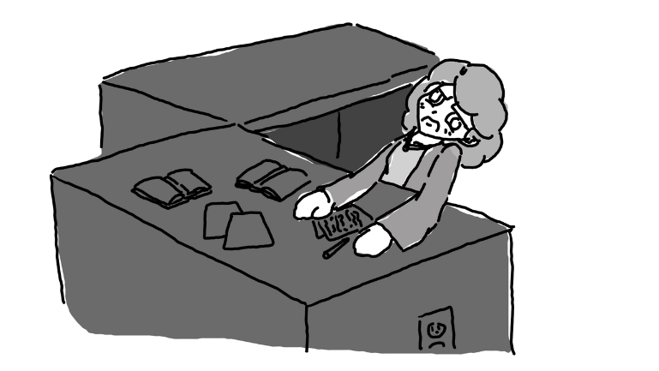
…Potions Class

The hominy was getting to her head. If she had to smell hominy for another ten minutes, she was going to go completely crazy - dump the tables over, spill the ingredients, knock over the microscope shelves, see if she could pull the whiteboard off the wall... the works. She wanted to kick something, scream, punch the walls, something, anything to relieve her stress.
Her lab workbook wanted her to get through twenty more experiments, and she knew that this labsheet was due tomorrow. She would have been motivated more if she found it relevant. Or interesting. Or she had more than ten minutes before the whole lab closed. Or even if it felt like it belonged here - turning water into hydrogen peroxide? What was this, alchemy? What did alchemy have anything to do with potions? Weren't potions good luck charms or transformation juices or something? Couldn't they just turn water into hydrogen peroxide without magic?
The clock was ticking. Every tick, a minute went by. She was sweating, and it made her feel disgusting. The words were jumbling up in front of her, and she had just about enough.
Who cared if the paper wasn't complete?
She packed up her bags five minutes before ten o'clock at night - when the doors locked to the science building. Gritting her teeth, she popped her backpack on.
It was a lonely walk back to her dorm, but the tone change upon walking in was immediate. It seemed like everyone - or at least the nerdier types - were out in the lobby. It was both guys and girls, since that particular dorm complex housed both guys and girls on different floors. They were all sitting around the common room television, enamoured with some sort of video game. She didn't think much of it, beginning to walk past the hubbub until she heard her name.
"MAPLE!"
She turned slowly. It was Enoki, a controller in her hand, staring at her, leading the rest of the crowd to do the same.
Maple gritted her teeth. "What?"
"C'meer! I need tah show you somethin'!"
Begrudgingly, Maple began to walk over. She figured that, if Enoki wasn't coming back to the room before long, that she wouldn't be able to get much sleep, anyway. But sleep sounded really good to her at that time.
"That a video game?" asked Maple.
"Uh huh!"
"Where's the keyboard?"
"It's from Nippon - it doesn't have one!" She shoved an awkwardly-shaped controller into Maple's hand. "It's a fighting game!! That's Nim over there, he's really good at it!"
Maple looked over to the couch in front of the television, reserved for the players but surrounded by an audience of nerds. On it was a sylph - sort of like a wind fairy, but the same size as everyone else. He had wispy white hair and skin so painfully white that he was indistinguishable from an albino human. He wore a hawaiian shirt and a smug expression, and the moment Maple looked his face, a bright cherry blush.
"What? You want me to play him?"
"Uh-huh!!" chirped Enoki.
"Fine," she groaned. "I'll play him."
She sat down on the couch.
Nim leaned over just a bit. "So you're Maple?" he asked, speaking a thick Oned Rikish accent.
"Yeah," she replied, not giving him eye contact.
"Cool, I'm a.. You need help with the controls?"
"Is it just this wiggly stick to move and the buttons to fight?"
He sharply inhaled. "Sort of, yeah."
The television script flashed text in Nipponese. Maple hadn't the faintest clue what it was saying, but she assumed that it had something to do with starting. The game started, and she was impressed with the three-dimensional graphics. It was much, much more realistic than the arcade games at the mall she sometimes would visit with her friends in high school. When she finally got a chance to see the fighting stage, was given a character with a design that was clearly aimed at a male audience. Go figure.
Then, the game started. Confused, she started pushing random buttons, getting frustrated and confused at how fast the two characters were punching and jumping. She seemed to be doing the same thing over and over again, no matter what she pushed, and he was flipping and kicking in ways she couldn't figure out. In no time at all, he had won, leaving her even more stressed than before.
She threw the controller on the ground, standing up and grabbing her backpack. "I hate it."
"Wait!" chirped Enoki, "Just one more time, please? I think you'll get it this time!!"
Considering her options for a moment, she slowly put her bag back down and picked up the bizarre controller. She sat back down, exhaling slowly.
"Hey, uh.." coughed Nim, "So, what I'm doing to do all those moves is-"
"Look, dude, I just got out of a class, I really don't want to start another one."
"Right, right, sorry."
The match restarted. She breathed slowly, trying to pick up on what exactly was going on. He landed a punch first, but she quickly responded with a kick attack. She smiled. It felt really good to land that kick.
As it went on, people started putting bets on who would win. She was still button mashing, but at least she had found some kind of pattern - halfway through it became clear that Nim wasn't holding back on her anymore. After all, if this game was new, then Nim didn't have all that much of an advantage over her, did he?
Enoki yawned, smiling. "Welp I'm heading up to bed. You guys have fun, ok? I'm keeping the Rokujuyon down here with the television."
Maple was listening, but because she was listening, she lost the match to a kick she forgot to block.
She turned to Nim, death in her eyes. "We're playing again."
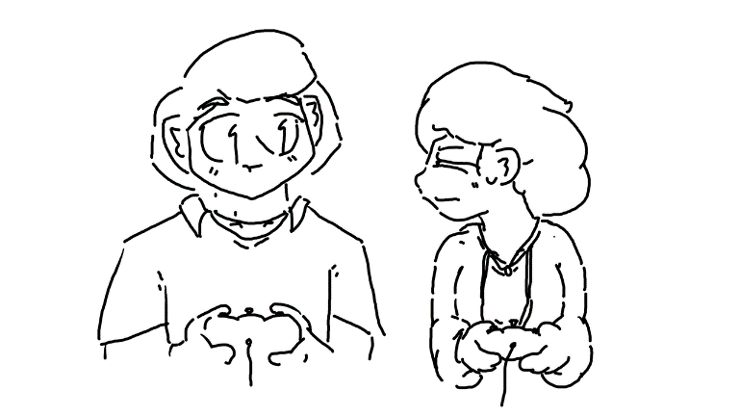
He shrugged. "I'm bon with that."
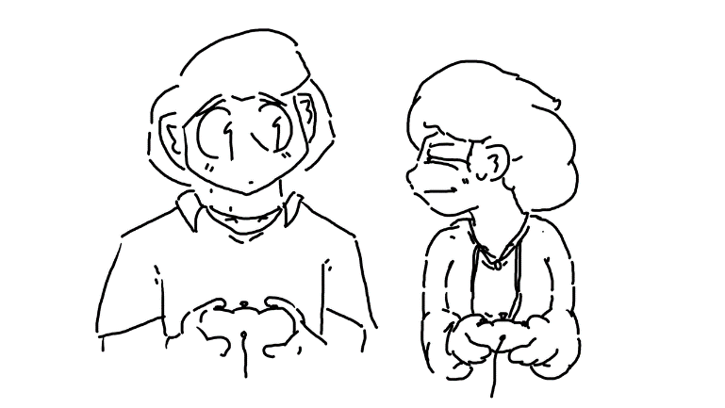

And Enoki was already gone.

Part Two
They actually do it

They Actually Do It

Maple had just about enough. Dinner was over, and it was just about time to lock herself in her room and pretend to be a plant. She dragged herself into her room, slung her backpack to the ground, and fell over into her bed. Using feel, she located one of the books she had due for a literature paper still laying atop her sheets, and with a single hand, she popped it open and held it over her face. There was no way she was going to be ready for her literature final by tomorrow - she wasn't even halfway through, and she wasn't even planning on being on campus tomorrow, but she couldn't think of anything better to do.
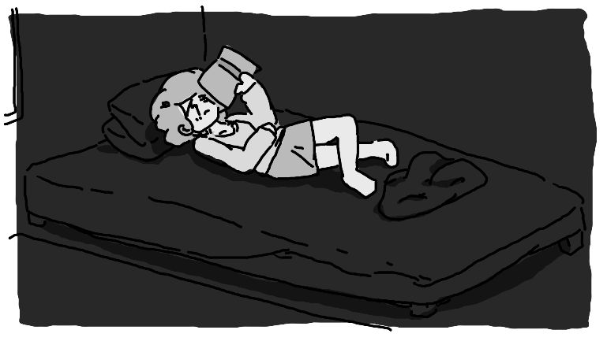

She could hear Enoki's footsteps as she ran through the dormitory hallway. In an instant, she was in the room and threw herself into her own bed, posing dramatically and ready to catch up with Maple.
"So whatcha readin'?"
"A book."
"...Cool."
"M-hm."
Enoki poked her brain for something to talk about. The end of the semester was coming up, so that could be a decent topic. "Sooooo... You want to get started packing?"
"I don't really want to do anything."
"Me either." Next topic. "You were worried about potions class, how'd that go?"
Maple slammed her book shut. No use in trying to read. "It's over. I don't ever have to think about it ever again."
Enoki gasped dramatically. "You passed? Was it the extra credit you took?"
"I lied about that extra credit so you wouldn't worry about me."
Enoki winced. "Ouch."
Maple sat up, letting out a heavy sigh. "Bon, so, you know that thing we were talking about? I'm in."
She squeaked in excitement. "For reals?"
"It's happening. I got my bag packed."
Enoki was rocked back in forth, nearly about to burst at the seams. "Uh-huh??"
"Get a map out and I'll show you what route I'm thinking."
In a heartbeat, Enoki snatched a map of North America out from one of her drawers. Maple had expected her to find it in one of her dozens upon dozens of pre-bought textbooks, but having a full-sized rollout map was going to make planning much, much easier. Upon closer inspection, though, Maple realized that it was a map of campus, not of the world. Huh... she could have sworn that there was a world map on the other side.
"There we go," chirped Enoki, "Map of the town."
"...Flip it over so we can see the whole country."
She flipped it over, and sure enough, there was a North America map. Weird.
"Oooh, ooh, I'm so excited!!"
Maple leaned in to draw on it with an erasable marker. "We're down here. Say we cut north, I'm estimating it should take us about two weeks on foot to get up north out of Carolina."
Enoki touched the map with her finger. "What if we just cut to here and take a taxi?"
Maple took a deep breath, sitting up. "Enoki... Taxis cost money."
"But food does too, and, I mean, the less days we stay out, the less days we gotta put in, if you know what I'm sayin'."
"...You do the math on that, I'm not in the mood-" She lifted a finger. "Wait, no, I don't know if I trust you to do the math on that."
Enoki giggled under her breath as Maple continued to plot their route.
Some time went by. Enoki had already gone to get snacks and then eat all of the snacks. Maple seemed obsessive, but she knew many of these roads. That, and they were two college-age girls, one of whom was an easy, highly attractive target because of her background. This wasn't going to be easy, whatever they were doing. Maple wasn't even sure where she wanted to go, at least not for sure. Just out of the Carolina Province. Somewhere up north. Somewhere that Aaron wouldn't think to check.
"Yeah..." sighed Maple, "This route should be painless. We just need to take the map with us and we're good as gold."

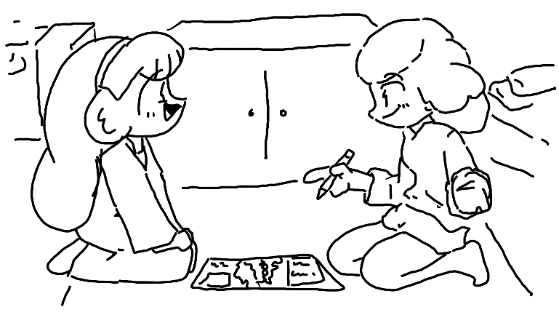

Enoki leaned in. "Can I pack snacks?"
Maple pointed at her. "Please."

Into the Woods

Campus was still visible, back behind a hill. In front of two girls was nothing but woods. Lots and lots of woods. It was the best way to escape without getting caught, but... it was a lot of trees. Maple stared at it as if she were attempting to figure out how to walk directly through a brick wall. That, and of course, whether or not this adventure would even be worth it.
"...Boo!"

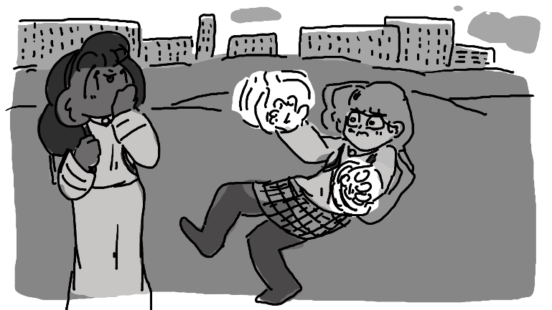

Foomp, said the ground, as she landed on it.
"Ahh..!!?"
"What, you scared of the..." She twiddled her fingers. "SpooOOoooOOky trees?"
"Aaron's probably waiting for me somewhere on campus in his car, and I'm disappearing into the woods," she replied with a thick undertone of annoyance.
"Well, yeah. He probably is."
"Did.. you, uhm.. Leave a note for everyone else like I suggested?"
Enoki put a hand on Maple's shoulder. "They'll understand."
Maple sighed in relief, knowing that Enoki probably found the perfect words to say to keep Aaron from worrying. It was like a boulder had been lifted off her shoulders. "Whew..."
So into the woods they went.

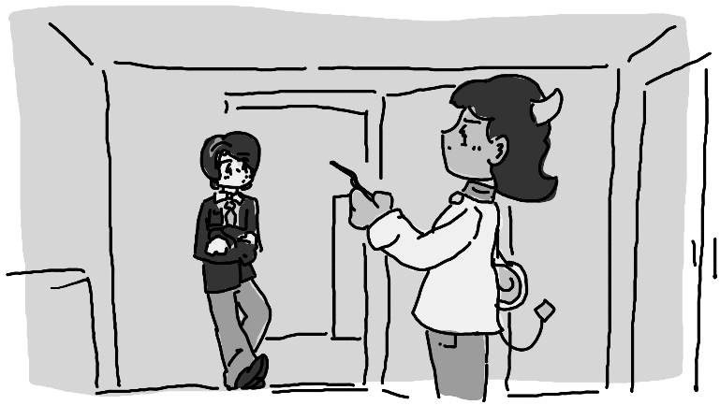
The Martians Leave a Note

Felix and Coralie had successfully infiltrated Maple and Enoki's room. That is - the door was left open and they walked in without permission. Felix stood by the door, coolly leaning against it to guard and make sure no one else had access to this treasure trove. Coralie had already made her way to one of the desks, picking up a note from the top and reading it aloud.
Coralie cleared her voice.

"Dear puny earthlings,
This note was written by Martians who have just abducted Enoki Ramirez and Maple Tremblay. Do not look for them, as we are busy dissecting them to figure out what makes them so awesome. Please continue with your mediocre lives as if this note never existed.
Thank you <3
- The Martians."

Coralie just stared at it, mildly confused. "Hmm. I wonder who wrote it."
Felix shoved his hands into his trouser pockets. "Who do you think wrote it?"
She scoffed, letting the note fall a bit. "I know who wrote it, I-..." That's when she noticed something fall out and begin to drift to the ground like a leaf. "Hey, look-"
"Yo, a fifty?"

Into the Woods (cont’d,)

A few hours of trekking went by. It was kind of remarkable that they hadn't encountered any roads yet. They hadn't eaten anything yet, but Maple was sure to bring a steel cup, one that she had owned since she was much younger - a few times, they would stop by a stream, and she would light a small fire underneath until it began to boil. They'd wait for it to cool off and then drink it. It tasted like dirt and had a grainy aftertaste, something Enoki wasn't familiar with, but at least it wasn't going to kill them.

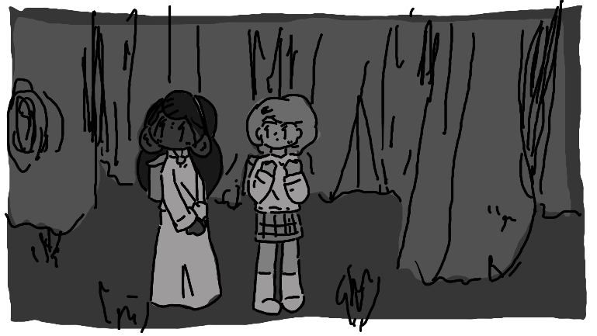

At some point, Maple eventually became hungry. She stopped, turning around and facing Enoki. "Alright, I'm famished, let's see what snacks you-" Enoki spun around, letting Maple see inside her backpack. "Um... Enoki?"
"Uh huh?"
"Did you mean to pack nothing but portabella mushrooms?"
"All the vending machines were in the student center!" She held her hands like a crooked businessman. "I had to bribe some workers in the dining hall to gimme all their extra mushrooms."
"Did they have literally anything else?"
"I mean, yeah, but.. What else do you need?"
Maple was short with her. "I'm intolerant to mushrooms. We've talked about this."
"Oh." She folded her hands in front of her and leaned back. "Well that.. would have been good to know earlier."
Maple groaned.
"Hey, but can't you just magically transform them into something you like?"
"I failed that class. Didn't you get an A?"
"I guessed on all the tests and got everything right, so I didn't actually.. uh.. learn anything."
Maple died inside. "Oh."
Over the next hours or so, Maple had decided not to eat anything at all, but the two made great progress. The sun had completely set and the two had decided to camp for the night. They sat on the ground around a bundle of sticks that Maple had caught on fire. It was a bit chilly, but not uncomfortable, especially near the fire.
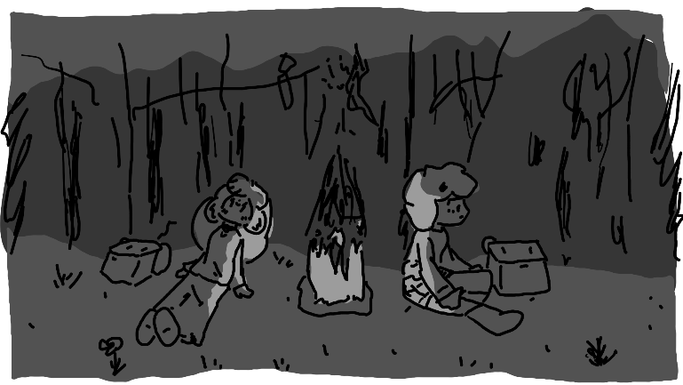

"Hey!" chirped Enoki, "You get the tent, Maple?"
"We weren't ever going to have a tent. How could we have gotten a tent?"
"A bedsheet or somethin'?"
Maple sighed. "Look, I'm fine just sleeping on the ground, that was up to you if you wanted to bring something to sleep in."
"Oh, I'm fine without a tent, just the stars above my head... and the creepy, crawly, death parasites from below, crawling in through my skin and mind-controlling me to drown myself in the ocean."
"...Enoki, this isn't Australia."
Enoki looked up at the stars. There were quite a few up there. "You ever think the stars looked like little fairies, and when they twinkle, it's like their way of saying 'salut'?"
"No, I think fairies look like fairies."
"You're no fun!"
Maple stood up and kicked the fire out. "Shh!"
"You 'shh'!"
Maple whispered harshly. "No, I mean, shut up and listen, I hear something." The two were quiet, and the house of horse hooves faintly echoed through the woods. "What's that?"
"Oh, probably the blind elves, coming to take away lost humans and hold them for ransom."
"Shut up!" she hissed.
"I'm serious!"
Maple sighed. "See, that's your problem, you keep coming up with stupid explanations for everything, and then I can't trust you when something serious happens."
"...Hey, Maple?"
"Yes?"
"If they're blind, why did you put out the fire?"
In an instant, the two of them were grabbed by their legs and held upside-down like sacks of potatoes. For only a split second, they could see who was before them - a dark rider on a dark horse, no eyes in his sockets, limbs stretched and far too long for his body, strength far exceeding his reach. Maple couldn't make a sound, she could hardly breathe- the wind had been knocked out of her, and her eyes were reeling as she tried to figure out where he stood in relation to her.
"I mean," pointed out Enoki, "It just seemed a little silly."

Felix and Coralie’s last dinner

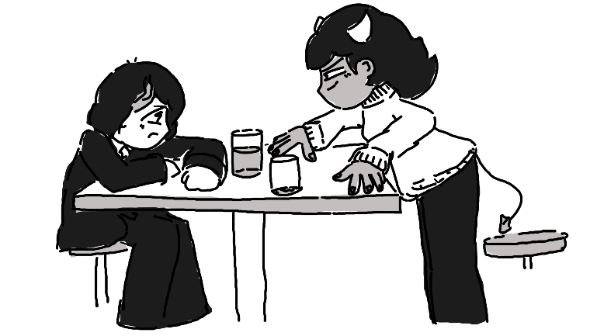

Felix stared at his glass of chocolate milk. He really didn’t want any more of it, but he understand that he was under oath – he had to drink it. There wasn’t an option.
In a huff, Coralie slammed her chocolate milk back onto the table. “I just did cup five. You?”
“Five, too… This has got to be the dumbest tradition on the planet.”
“So?”
He held his breath, downing yet another glass of chocolate milk. These bi-weekly challenges had turned his love for the stuff into a deep-seated, burning hatred, but he had to do it. This was the last time they’d be able to hang out in the dining hall over lunch until the semester picked back up. And if Coralie was going to do it, then he wasn’t going to let himself get shown up.
“So,” sighed Coralie, wiping the milk off her pink face, “How you feeling?”
“Sick,” he replied, wanting to take a trip to the restroom to purge his stomach.
She chuckled. “Think about how I feel. Milk tastes sour to Tieflings.”
He stuck his tongue out. “Why are we doing this?”
“I thought this was your idea.”
“I…” he groaned. “Bon, I think we’re done. Five is a good limit.”
“Oh, I meant that I had five before that glass. I’m on six right now. You’re gonna have to get another glass if you want to be even.”
He frowned. “Fine.”
“Hey- before you go,” she leaned in, “You wanna talk about that note? I mean, have you seen Enoki or Maple anywhere on campus since then? You don’t suppose they.. just.. left, did they?”
“We’re all adults, we can do what we want.”
Coralie kept her voice down. “But Enoki Ramirez of all people, do you think… I don’t know, don’t you think it’s a little suspicious that she left without any security or anything? Being that famous?”
“Well, when you put it that way… Dude, you don’t think she’s gonna go missing and they’ll have some kind of ransom, do you?”
“That’s exactly what I’m thinking.”
“Dude, how rich do you think we could be?”
“Famous. Rich and famous.”
“Right, right…”
Coralie leaned back and stretched. “Well, I’ll get my car ready.”
“Wait, we’re heading out tonight?”
“Yeah! Who knows where they’ll be by tomorrow? Let’s do some interviews with people on their floor and see what we can learn first, and then get a move on! After you drink one more chocolate milk.” She grinned. “I’ll wait.”
He groaned deeply, standing up. “We’re picking another stupid tradition next semester, çé bon?”

Now they half to escape

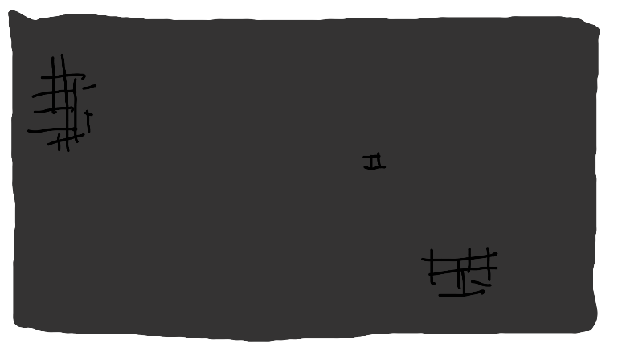

When Maple finally came to, it was just about impossible for her to not panic. She was sitting on a chair, hands tied behind her back and a sack over her head. It smelled like corn. Almost immediately, she began to hyperventilate, trying to use her powers to burn her way out, but... nothing seemed to happen.
"I.. I-I.. I can't burn my way out.. ENOKI, I CAN'T BURN MY WAY OUT-"
"Hey, calm down." Her slightly muffled voice was coming from right behind her, facing away. She might have been tied up to a chair, too.
"WHY THE HECK SHOULD I-"
A big wooden door creaked open, and a gruff voice from the other side opened it up. "HEY, COULD YE KEEP IT DOWN? We're trying to make some phone calls and count up ransom money, geez!"
Maple would have easily burned the entire place down then and there if her fire powers were back.
"May I have a glass of water?" asked Enoki.
"NO!" the guy shouted, slamming the wooden door shut.
Enoki frowned. "Well," she whispered, "That guy's rude."
"I-I can't believe I did this.." whimpered Maple, "I-I can't believe it, I'm gonna die here.. I have no idea what they're going to do to us, and it's all my fault.. I-If I wasn't so selfish, I.. I-I, well, I guess this is what I wanted.. Now Aaron's not going to have to worry about me getting in the way of his life anymore, I'll just be dead somewhere in the middle of the woods, and-"
"Hey, Maple?"
"What?" she hissed.
Enoki's grin could be heard in her whispered voice. "They tied mah sleeves and not mah wrists, so I just slipped out, stay quiet." And in a moment, the sack from Maple's head was whipped off. "Ta-da!"
"Why aren't my powers working?" hissed Maple, still trying to burn her way out of the ropes, which had been tied to her wrists instead of her sleeves.
"It's prolly that thing on your ankle," she pointed out.
Maple lifted her leg. Sure enough, there was a small device tied to it with a pulsing crystal sticking out the front. She had never seen anything like it before. It must have been dark elf magic that the blind elves were borrowing for some reason. She tried to use her fire magic, but instead of producing fire, the crystal began to glow. It must have been absorbing her energy or something. She wasn't really sure what it was doing. They probably talked about this in one of the classes she slept through.
"As long as that thing is touching you, it's going to absorb all of the energy from your skin," commented Enoki, "So..." She grinned, covering her mouth with her hands and trying not to squeal. "Bon, so, I've got an idea, you won't like it, but I've always wanted to do this on somebody else, and-"
Maple glared. "What on earth are you talking about?"
She held her arms out. "We're in a barn, yeah? There's a box over there and a saw over there, and... Well... I'm a magician..."
Maple's eyes widened. "No. No, no, no. You are not sawing me in half."
"It's ok!! It'll just be for a second so we can take care of getting out of this smelly old barn! I did it to myself all the time growing up! It freaked my nannies out, like, super bad, but they go right back together!"
"I..." she sighed. "I guess we don't have an option, do we?"

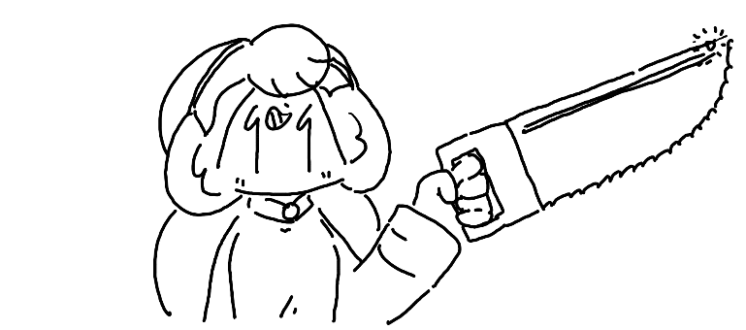

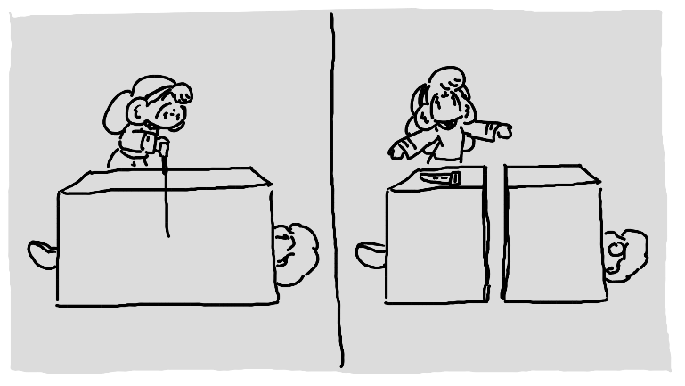

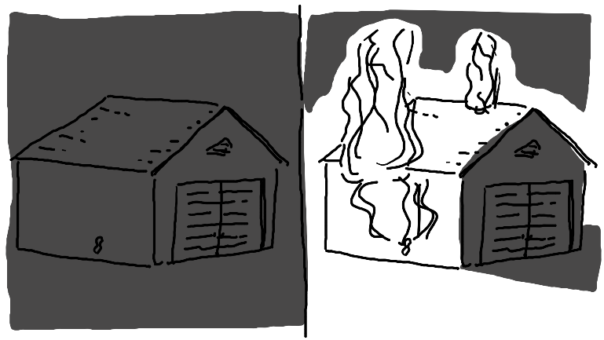
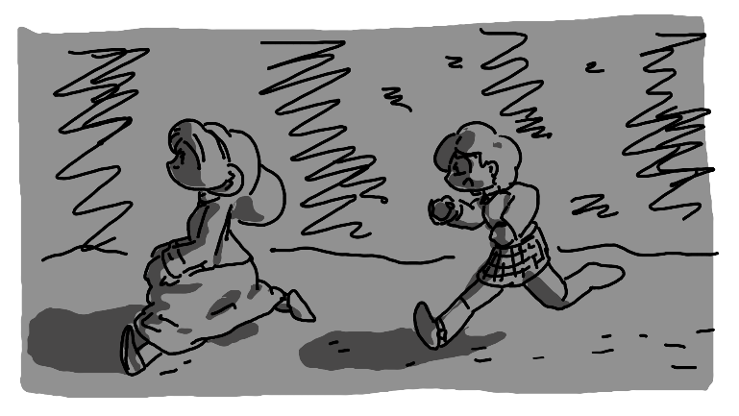

The two were running away from the barn as fast as they could. They chased their shadows - the light of the barn was enough to give them a good sense of direction. To their benefit, they knew that the blind elves were particularly keen on sound, but the sheer roar from the flames, and now exploding gasoline, should be enough to keep them off their trail. They were exhausted, but they were also terrified, so that did wonders to their sense of motivation.
Finally, after a day of traveling, the two came to a road. The sun was just coming up over the horizon. How long had they been there asleep? Were they using some kind of sleeping spell to keep them there? Maple didn't want to think about it, nor did she want to know what would have happened if they had stayed there - they were safe now, or at least it seemed like it.
"Hey, Maple? Where are we, do you think?"
"I don't know. Farther north. We need to find some place to get this band off my leg."
"Prolly a locksmith in town'll do it. Let's find a bus stop and go!"
"Enoki... Those.. cost money. They stole our backpacks. You're going to have to realize one of these days that-"
"Hey, Maple? What's that behind your ear?" She reached behind Maple's ear, gasping and retrieving a note. "It's a twenty!"
"Hold up, can you just pull whatever you want out from behind people's ears?"
She giggled. "How do you think my family got so rich?"
"I... don't know how to feel about that."
Enoki rolled her eyes, opening her sleeve to reveal a hidden stack of bills. "I guess I'll let you know this one trick. Let's go find a bus!"
"Yeah, let's."

Nim sees suspicious activity

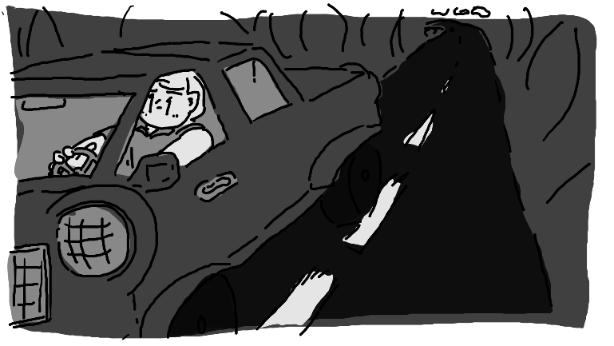

Somehow the semester was already over. It didn’t feel right, but it was. And to think – he had finally worked up the courage to ask Maple out. Like, for real. To coffee. Or something. Not that he could find her anywhere – she’d been missing for a day. He figured she’d just up and left already. Figured. She probably didn’t think much of him anyway.
Ring… Ring… Ring…
It was his parents again for the four-hundred thousandth time. No, he didn’t need their help moving out – they lived twenty minutes away, he could easily back into their place by himself. Besides, he needed the time by himself. No parents, no Maple to distract him from-
And then a familiar face popped up on the side of the road. It was just for an instant, but Nim swore that he saw Maple Tremblay and Enoki Ramirez walking to a gas station. Strange.
Yeah, he didn’t care much to be alone anymore.
Quickly, he turned his car around and drove up the road to find them. The gas station wasn’t all too far away from a bus stop, and just as he caught sight of them again, he saw them hop onto the bus. He squinted, paying close attention to the license plate. MBL-002. He needed a pneumonic to remember it. Maple Bourbon Latte. Mmm… that was his favorite order from his local coffee place, a place he really wanted to show Maple if he would have been keen enough to have asked her out a week ago instead of today.
Yes, he knew it was a bit creepy to be following them. He was prepared to deal with that. But something about the two disappearing from their dorm, especially Enoki, who he half expected to be taken home by helicopter, didn’t sit right with him. He wanted to figure out what was going on. And to give him a decent excuse from having to call his parents back.
They started driving away. For a moment, he considered chasing the bus, but instead, he raced back to the school. He was only about ten minutes away, after all. In the meantime, he’d make a phone call.
“Yes, this is Nim McNeely. I’m requesting a secondary officer. I think I’m on the cusp of a missing person’s- No, I swear this is a real case, I’m not just pranking in again… No! No! Of course not! I-… It’s about Enoki Ramirez and Maple-“
They hung up.
He sighed, driving back. If they didn’t listen to him about his rapidly forming suspicious, he’d just go tell them in person.
Ring… Ring…
Why on earth did his parents keep calling him?
He peeked down for a second, and no- this was the university police department calling him back. He picked back up, confused.
“Hey, Nim, we got word from the police chief. He wants you to report back immediately. He has a few words to speak with you. He says it’s very important.”
Hoo boy, this was going to be fun.
When Nim pulled up to the police office, he dashed in. He almost never went in without his uniform, but that wasn’t relevant at the moment. He hesitated a bit, but he found himself in the university police chief’s office, sitting across from a desk. He hadn’t met the new chief in person yet, he was always busy at the wrong times, but this was one heck of a first meeting.
The chief himself, a green orc with thick eyebrows, had very little decoration, aside from a nameplate reading Chief Maurice LaPointe. He stared him down silently.
“I… er, is there anything you’d like to talk about?” asked Nim, confused by his silence.
The chief pushed a button on a small tape machine. It seemed to be wired to his office phone. “Bonjou,” it spoke, “We’re here on behalf of the Maria Ramirez Development Foundation. Our Maria Ramirez retrieval agents noticed that her room was notably vacant. For security reasons, it is of great important that her disappearance is top-secret. Anyone who knows of their wearabouts is to remain undercover and act with discretion. Anyone who aids with the retrieval of Maria Ramirez, without bringing external attention, will be awarded a sum of 1,000,000 Laurentide dollars.”
Nim froze. “You’re… um… you’re serious, aren’t you? Does that mean they’re gonna pay me a million dollars just for not telling anyone about this?”
Chief Maurice nodded.
He laughed, leaning back. “Wow. This was not what I was expecting. I was fully expecting to get fired or something. So, um, anyway, I know their license plate number. I caught sight of the bus they caught while I was heading over here.”
He leaned in.
“Yeah! MBL-002.”
The police chief stood up, grabbing his keys off his desk. He walked over to the door, gesturing for Nim to follow. He didn’t smile, smirk, or even show his eyes, so Nim wasn’t quite sure what to expect.
Goawn was lounging in the lobby. He was supposed to be the station dire wolf, but while he was almost big enough, his behavior would have fit a loaf of soggy bread much more fittingly. Police chief whistled, and Goawn poked his head up, rolling around until he was within hand range. The chief kept walking out the door, the dog waddling close behind, Nim at the flank.
“You’re not… taking me with you, are you?”
Maurice nodded, getting in the drivers side seat. Nim climbed in the passengers’ side, and Goawn barely squeezed into the back.
Nim’s face was full of a goofy grin. “One million dollars… I don’t even know what I’d do with one million dollars. That’s enough to live on for, like, what, the rest of your life or something? Or maybe just one year, but it’d be a really fun year.”
Maurice put the police car into gear and began to drive. No questions, no phone calls, no intercom, he just drove. The longer it went, the more unnerved Nim became by the whole thing.
“So, um, the other officers say you’re a really good speaker. Always saying inspirational things.”
“…”
“Are you not going to make any phone calls? Was that license plate enough to figure out where they are?”
He nodded.
“Dang… You’re good.”

Old lady purse thieves

“FELIX!”
“Hmm?”

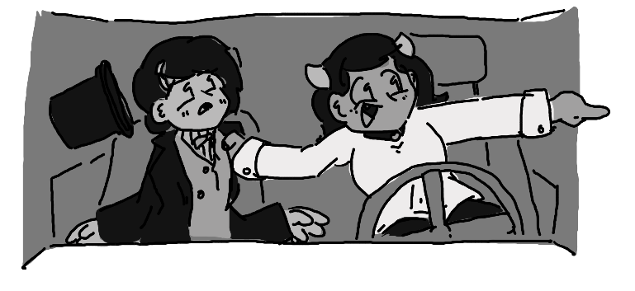

Coralie was shaking him by the collar of his suitcoat. “Look at that bus!”
Felix, who had slumped over asleep in the passenger side of Coralie’s car, sprung up to take a look. They were parked at a gas station not all too far away from a bus stop, and at that bus stop, boarding the bus, were Maple and Enoki.
“Is that them??”
Felix squinted. “Yeah… Yeah, I think so.”
Coralie tried to start her car up. It turned over a few times, but it wouldn’t start. She hit the steering wheel with her palm in anger, Deeply confused by this, Felix started at the dashboard. No, she wasn’t out of gas. The battery seemed fine.
“What the heck?!” she screamed, face turning a bright cherry red.
“Dude, when was the last time you changed your oil and filter?”
“It was just…” She looked up at the sticker. “I was supposed to get it changed at 150,000 miles.”
“And how many miles do you have on it?”
“…a lot more than that.”
“Oh.”
“Hey… You mind going inside and getting some snacks? I’m fine with anything spicy. I’m just going to be in the car screaming and I don’t want you to hear me. Here’s a ten.” She handed him a bill. “See ya’ in a bit.”
“Yeah, hehe, you too…”

…

After a few moments, he returned with some snacks in tow – two bags of spicy Gusanitos chips, some Beignets, and two bottles of cola. The closer he got to Coralie’s beater, the more he expected to see her in distress, but in all honesty – she was fine, just listening to some radio on what little car battery she had left.
“I.. got you your favorite chips,” he said, “And you can have some of mine, but I know you’re not really into hors d'oeuvre.”
“Oh, thanks! You’re a good friend.” She started chowing down into the chips.
Felix opened one of the sodas. “You, um, you look calm now.”
“It’s fine. I just needed to take out some of my anger, now I’m happy.”
“Hey, um… The bite mark out of that telephone pole over there, was that-?”
“I’m happy now. That’s all that matters.”
They ate their food in silence for a bit.
“So what now?”
“I’m debating calling my dad,” she replied.
“We could call my uncle, he lives-“
“We’re not calling your uncle, thank you very much. I want to keep both of my arms by the time the day is over.”
Felix squinted out the window. “Hey, you see that police car at the red light?”
“Yeah?”
“Isn’t that Nim? The sylph? Didn’t he have a crush on Maple or something?”
Coraline squinted over at Felix. “How would you know that?”
“I mean.. that kind of stuff gets around. Didn’t you see them play City Fighter every other day for the past few months?”
She crossed her arms. “I guess I’m just not a perceptive person.”
“We got to get their attention.”
Coralie slammed her chips down into the dashboard and jumped out of the car. “Follow me – I’ve got an idea!”
Down over by the bus stop was a bench. A little old lady was sitting down, holding a purse in front of her. She seemed to be a Mònn d'Plonj – part dragon, part human. This woman where Coralie’s undivided attention was. Felix did his best to catch up, but by the time he was there, she was already in cahoots with the old lady.
“Hey, can we pretend to steal your purse?”
The light turned green.

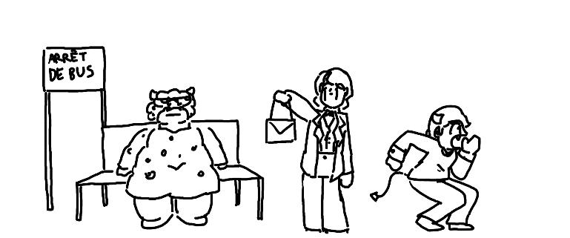

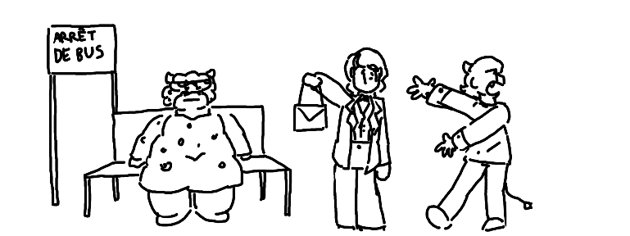

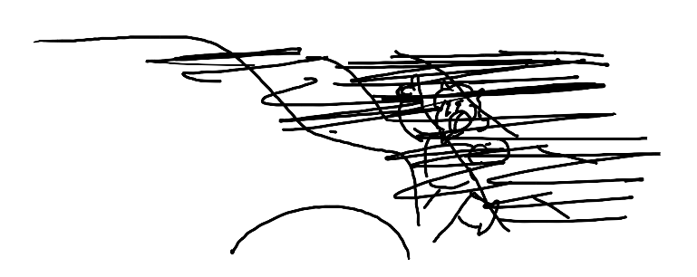

“Well… that didn’t seem to work,” commented Felix, going back to pick up the top hat that he dropped on his way over there.
“I blame you, Felix!” she shouted, handing the old lady back her purse. “Thank you for the purse, you were a gem.” Then, she turned back to Felix. “Everyone knows you’re the least suspicious person on campus!”
“No I’m not!” he shot back. “I’m mysterious! I promise!”
She crossed her arms. “Whatever. Time for Plan B, I guess. Hey, Felix, was there a pay phone in the gas station?”

After the tiny bus naps

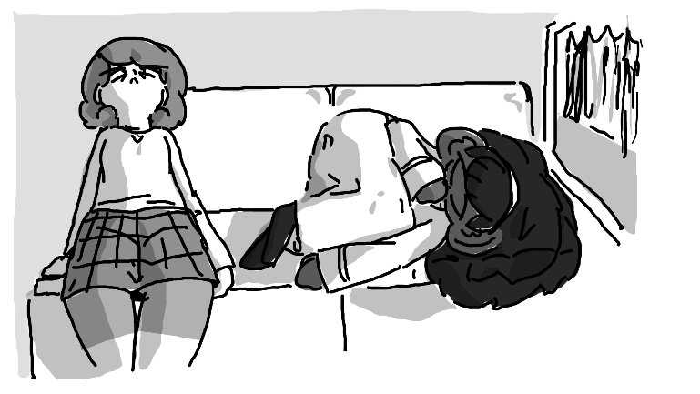

Maple did indeed sleep on the bus, but it wasn’t a good sleep. She kept having flashbacks to the time she blind elves snatched her. She occasionally rubbed her stomach, not going to be able to put the fact that she was cut in half behind her. She kept wondering how this trip was going to go from here if that’s what happened on the very first night. She probably dreamed something in the meantime, but it wasn’t much, and she immediately forgot it.
And then there was Enoki, curled up and dead asleep – even snoring just a bit. Maple could not fathom how on earth this girl was always so calm, and then she remembered it. Oh, yeah. She has lots of money, what could she possibly be afraid of?
She peeked out the window, trying to figure out where they were. It seemed like the hours spent pouring over a map were pointless. Then again, they were probably pointless anyway – she didn’t know where she was going, not really. She never felt passionate about anything other than leaving the providence.
Maple had about enough of Enoki’s sleeping and started poking her on the shoulder.
She sat up, stretching like a princess from a movie. “Uh huh?”
“We need a plan.”
“Hm?”
“I don’t know where we are, and we don’t have any of our supplies. We need to figure out what we’re doing, and fast.”
She rubbed her eyes, yawning. “Why not ask the lady behind us?”
“Enoki, you can’t just talk to people on the-“
“Hé!” she chirped, turning around.
The lady behind them smiled. “What do you need, honey?”
“We’re both a little lost, where are we again?”
“This bus is on the way to Montbéliard,” she answered. “Where are you two off to?”
“We don’t know,” answered Enoki, “But we got captured by some blind elves, and then we escaped, and we’re trying to get away.”
She looked serious. “Bless your hearts… That’s incredibly fortunate of you two, getting out of there.”
“Thank you! Oh, so where are you going?”
Maple winced, trying to stay out of the conversation. She can’t believe that Enoki had worked up talking to a complete stranger about events that she was still trying to process, and to block out the noise, she did her best to figure out what exactly they needed to do to fix everything.

- Get this magic anklet off.

- Buy some new clothes – maybe a hair color change would be appropriate.

  - I want to choose something that won’t stand out too much but also won’t look like me. Purple? No. Dark brown? Maybe. We’ll see.

  - Oh… We’ll need to come up with fake names. That might be useful. What’s a good one for me? L-something would be fun… Lucretia? Hmm… I like that one.

- And then… ???

Enoki stood up. “It was very nice to meet you, Ms. Green! Congratulations on your son’s wedding!!”
“You too, Maria! Stay safe, you hear?”
Maple noticed that everyone was standing up and getting off the bus. It was probably just as good of a time to get off as ever – the bus was inevitably going to loop back around anyway.
“Maria?” she whispered, “Is that your fake name?”
She giggled. “No, it’s my real name!”
“You mean Enoki isn’t your real name?”
Enoki gasped playfully. “It’s my nickname! You never knew that? What kinda name is Enoki? It’s a kinda mushroom!”
“I’m not Filipino, I don’t know what names are normal over there.”

Meanwhile with Nim…

Maurice was silent for the car trip. Nim could not be more confused, maybe save for the fact that Maurice thought it was a good idea to bring the department’s incompetent loaf-of-bread dire wolf. Combining those two factors was the fact that Maurice had decided to roll down the window for Goawn, letting the flabby thing stick his face out the window. Nim thought it looked hilarious.
“You know,” he thought, “I wonder what that dog is thinking.”
So, he rolled down his own window and stuck his head out. He could see why it was fun – he looked like a fool, but it was definitely refreshing.

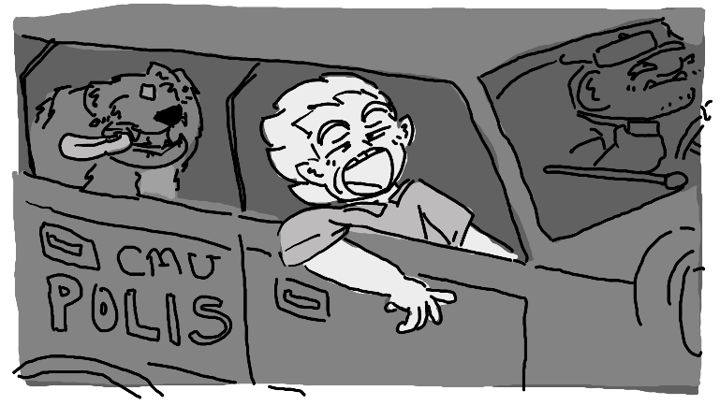

When he popped his head back in, Maurice was on his radio.
“Yes,” said the voice on the radio, “You should be coming up on the bus. Keep a low profile, we’ve already got some officers there.”
Nim sighed, having missed a chance to actually hear Maurice’s voice. Or maybe he didn’t talk. Maybe the person on the other side just knew what Maurice was thinking.
In front of the police car was a bus, pulled over. A few other cars were there, officer standing intimidatingly outside of the car.
“Nim,” said the voice from the radio, “We’ve had a talk and have selected you as the best possible person to go in and confront the pair. We don’t want to make either of them nervous.”
How long was his head out of the window?
He took a deep breath and stepped out of the vehicle. Then, walking over to the bus, he noticed that all eyes seemed to be on him. Creepy.
On the inside, however, he couldn’t find them.
“Bonjou? I’m.. looking for a Maple Tremblay and a-“ he then remembered that it might be best to keep Enoki’s disappearance on the downlow. “A… no one else, just Maple.”
Everyone just stared blankly back at him.
“Bon,” he sighed. “Did she pay of you to be quiet about where she is, or…?”
More blank stares.
He made a few laps through the aisles, looking to make sure no one was hiding. Annoying. Apparently that million dollars was going to be a little harder to acquire than anticipated.
At some point he just gave up and left the bus, immediately surrounded by questioning officers.
“Alright, alright, they’re not in there!” he ended up replying, “How are we supposed to find them now?”
One of the officers pulled out a radio. “We’re moving to plan B.”
“Plan B?”
“Running PSAs around town,” she replied. “We want to keep it on the down-low, so it’ll just be locally, but time is of the essence.”
He nodded. “I get that.” Then, he walked back to Maurice’s police car. “So… what now?”
Maurice pointed at a restaurant across the street.
Nim grinned. “I’m all for that.”

Mama Mia (here we go again)

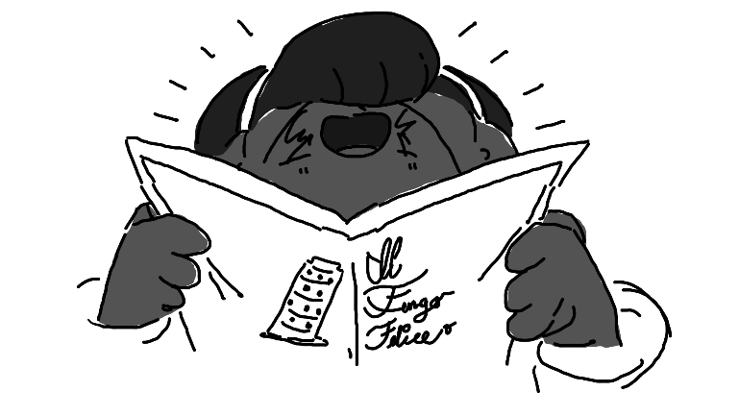

From the entrance to the seating to getting their complimentary breadsticks, Enoki was squealing the entire time. Maple had ignored it for most of the time, excited that she got to order whatever she wanted off a real Italian restaurant menu, but confused as to why Enoki was so excited.
“Hey, uh… You feeling alright?”
She leaned in and whispered. “I’ve always wanted to eat at a restaurant like this!!”
“But you’re rich, can’t you do whatever you want?”
She shook her head. “I had a security team escort me places, and we couldn’t go anywhere unless it was fancy or special enough. But we’re in the middle of the restaurant, ordering like normal people, and no one’s trying to get my autograph!!”
Maple thought about that for a moment. “You know… I always wanted to go to a restaurant like this, but I never could because everything on the menu was excessive. I mean, I could go for my birthday sometimes. Sometimes Aaron would save up enough for me to get to go on my birthday. But it wasn’t every year. So, this isn’t normal for you either, huh?”
“Nope!!”
Maple raised an eyebrow. “Interesting.”
That’s when she noticed something on the restaurant television, though. Enoki’s face, followed by a short message.
“This is Enoki Ramirez. She is currently missing. If you have seen her, or know someone who has, please contact this number – 1 800 192 4509.”
When Maple turned back to Enoki, she had taken her cloth napkin and thrown it over her head. Her ears were still poking out the bottom, but most of her head was concealed.
The waiter returned with their drinks. “Do I want to know?” she asked, staring at Enoki’s napkin head.
“I’m very ugly,” she replied, “And I am ashamed to show my face in public.”
He made a weird face. “You can’t be that ugly. You seem pretty cute to me.”
“You don’t understand! Do you see my ears? It is because… I am related to dumbo. Yes, that dumbo. I have the face of dumbo. It’s terrible, really.”
“So, you have the face of a cute cartoon character?”
“Yes. It’s hideous.”
He shrugged. “Alright…” he sighed, “But if you ever want to give me your number, just let me know. What can I get you two?”
They both ordered lasagna with a soda on the side, and the guy headed off back to the kitchen.
“So that’s how you get guys,” pontificated Maple, “You put a napkin on your head. Fair enough. But, uh, we need to find a way out of here…”
That’s when she saw Nim go in through the front door. With an orc police officer.
She immediately ducked under the table, doing her best to keep her head away from the gum stuck to the surface. “Enoki,” she hissed, “Down here.”
Enoki popped under the table, lifting the napkin out from over her face but not taking it off.

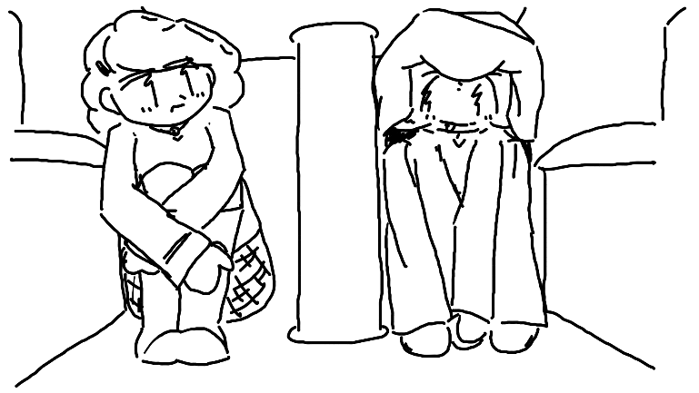

“Bon, Nim’s going to recognize me.”
“Put a napkin on your head!”
“No! That’s not going to work!”
“Why not?”
“We need to escape. How are we going to get out of here?”
“Fire exit!”
Maple sighed. “Enoki’s that’s going to cause everyone to panic and look at us.”
“Not unless there’s a real fire.”
“That’s way too far.”
“Even a little one?”
“Besides, I can’t make fire. I have this thing on my ankle, remember?”
“Hmm… How about… We pretend to be waitresses and escape through the employee’s exit?”
“Too many things could go wrong.”
“Just walk out the front door with napkins on our heads?”
“No.”
“Escape through the air conditioning vent in the restroom, crawl our way to the outside, and then embrace freedom-“
The waiter from earlier stopped by and peeked under the table. “You, uh… You two chers doing fine down there?”
“We need to escape,” whispered Enoki, “Someone who knows mah’ friend Maple here, he’s out there and we don’t want him to find her.”
“I see,” he answered. “Well, you can come with me and I can take you both out the bad-date door.”
“You have a bad-date door?”
He chuckled. “This is an Italian restaurant, of course we have a bad-date door.”
“Here- why don’t you both get up and hide your face with menus like normal people?”
Maple popped up and grabbed a menu, hiding her face behind it. Then, Enoki did the same thing, taking off the napkin for half a second.
The waiter gasped a little. “You were on TV-“
“Shh! I’ll pay you a hundred bucks if you don’t tell anyone!”
They started walking towards the back, face suspiciously obscured by menus, but… no, it didn’t seem to work for very long.
“Hey, uh, Maple?” she heard Nim say.
Yeah, it was over.
She tossed the menu to the table, and Enoki did the same. The whole restaurant, who had not cared at all that Enoki was in the store before the advertisement, was now staring to see what would happen next.
“Hey! We need to talk!”
“NO!” she shouted, grabbed Enoki’s wrist and darted towards the fire alarm door – it was the closest. The alarm immediately went off, as people got drenched with water from the sprinklers and loud sounds echoed through the building, equally disappointing everyone in the entire restaurant.
“AFTER THEM!” shouted Nim, who had Maurice right by his side.
Maple and Enoki burst through the door, immediately scanning the immediate vicinity. Enoki started running towards a random convertible jalopy, and not seeing much of a better option, Maple ran to the back tire, grabbing a spare key and then hopping into the driver’s side.
Nim was almost there, being marginally faster than Maurice, but it was too late. Maple had stared up the car, put it in gear, and slammed on the accelerator.
Nim took note of the license plate number.
“WHOOP!” shouted Enoki, “This is so excit-‘
“SHUT UP!” replied Maple, frantically trying to merge into traffic. She did, once and once again, the two were on the road.
Enoki’s stomach growled. “I’m still hungry- you wanna get some drive through?”
“NOT NOW!”
“Hey, calm down miss crazy-britches.”

Coralie’s Dad

“Hey, Felix, why are you always so nervous around my dad?”
“N-No reason, none at all.”
His station wagon was parked at the gas station, and Felix was once again within twenty feet of Coralie’s father. He seemed unassuming – dad bod, bald head, goofy grin on his face all the time, but Felix knew that this Tiefling had seen things. He didn’t know much, just that he was involved with something in the military. Something that probably won’t be declassified until after Felix was dead.

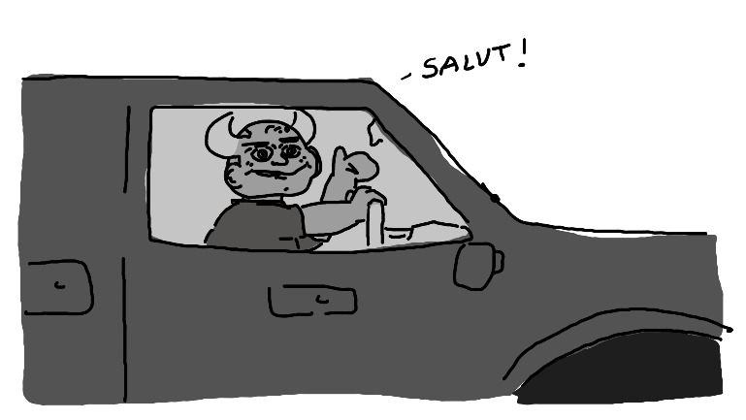

Mr. Lefebvre opened the passenger side door for his daughter, occasionally glaring at Felix, that smile still stretched across his face. “So,” he asked, “What do you think we should do with your car? Have you talked to the gas station owner about keeping your car here until we can get your grandfather’s tow truck?”
“Yep!” she replied, getting in. “I’m sorry that I made you come all the way out here.”
He shrugged. “It’s your car, this is a learning experience. I’m just glad I get to see you – it’s been months.” He glared at Felix through the window. “Has he been a gentleman?”
“Of course! A perfect gentleman.”
He started driving the car back onto the road. “Good, good. Won’t have to use the wood splitter on him this time, ho ho!”
Coralie laughed. Felix made a noise that faintly resembled laughing. Mr. Lefebvre laughed as to hide his thick, complete seriousness.
“So, you… you know Enoki Ramirez, right? Amihan Ramirez’s daughter? Well, they up and ran one day, but we spotted them, and we think there’s a decent chance that we could rescue them.”
“Imagine your parents being famous enough that everyone treats you like a child… I’m so glad you don’t have to live like that, Coralie. What I did in the military won’t be declassified for at least two more decades, ho ho!”
Felix’s mind started racing.
“Do you think… Do you think we could get enough money from finding them to buy a new car for me? Or maybe just bribe them out of money to keep them secret?”
He grinned. “That’s my baby girl. Just like your old pops. Of course.”
“And maybe we can get something for Felix! He’s been super helpful!”
“Hmm, like what?” he looked at him through the rear-view mirror. “What would you like, Felix?”
He nearly choked on his breath. “I’d just like to make it through this trip alive, he he.”
“Good choice! So, Coralie… I was listening to the police radios, as I usually do, and I caught wind of a missing person case involving two females. Is that a lead you’re interested in following?”
Of course he listens to police radios, thought Felix.
“Çé bon!” replied Coralie. “So where do we head off to first?”

An Outdoor Shopping Centre

The two had decided to drive through and pick up some Chinese food. Maple parked the car in the middle of a busy parking lot, just in the shade of a tree so the sun wouldn’t be unbearable. They had began to chow down into it, both of them enjoying it for the most part.
“Hey,” pointed out Enoki, “We didn’t have to pay for those breadsticks.”
“Now we’ve got the whole city – or country, I don’t know – trying to find you,” Maple pointed out. “And we stole a car. Now we’re legitimate criminals.”
“Hmmm… Let’s make a shopping list! Look at the shops!” Enoki went down the list, pointing at the different shops, “We’ve got a grocery store, a furniture store, a mattress store, a video rental store, a mattress store, a… another mattress store, and a tool store!”
That got Maple thinking. “What’d you say we swap out the license plates of this car? To stay off the radar.”
“Yeah yeah!”
So, the two finished their food and wandered into the hardware store. Once again, Enoki acted like a kid in a candy store, immediately dashing out of Maple’s sight and to who-knows-where. At least Maple had an agenda. She found some magic pliers… they were expensive, but she was sure Enoki should be able to cover it, and besides, it was important to their safety. Then, she picked up a Philips-head screwdriver. Unable to think of anything else that she would need, she stopped by the front, where Enoki was already chatting it up with the guy behind the desk, holding a garden gnome.
«¿¿Cómo debería llamarlo?? », she asked.
The guy paused for a moment. «¿por qué no le preguntas a tu amigo?»
“…What?” asked Maple, “In French, please.”
“We’re trying to name my gnome!”
“Uh… Mr. Gnome?”
“That’s boring!” criticized Enoki. “I love it!” Then, she turned to the cashier. «Sr. Gnome y todo lo que lleva, por favor.»
The moment they stepped outside, Maple leaned up against a pillar and began trying to remove the anklet. “I didn’t know you spoke Spanish.”
“I do! I speak French, Anglish, Spanish, Nipponese, and a little bit of Tagalog!”
“What’s Tagalog?”
She started moving around Mr. Gnome and speaking in a deep voice, as if he were speaking. “It’s the Filipino language, Maple, don’cha know?”
“So, it’s not your first language?”
She shook her head. “Nope. And I’m not trying to learn it very badly.”
“Why not? Isn’t that important if you’re a, um, citizen of the Philippines?”
“Because it’s the only language my parents speak,” she said, completely nonchalantly.
Maple finally popped the magic anklet off. What looked like a small ghost flew away, as the stone slowly lost its glow. She sparked a few flames off her fingers smiling before she gave a concerned face to Enoki. “That sounds like a can of worms.”
“It is.”
Annoying that, without her backpack, she didn’t have any pockets, she stuck the anklet in the side of her skirt to keep it safe, just in case it still had magic. “Do you want to talk about it?”
“Not right now,” she said quietly.
Maple took a moment to wait. Enoki hadn’t been this quiet for the entire trip. She nodded, understanding that this was something to return to in the future. “Alright. Let’s go get that license plate taken care of.”
The two walked back to their car. A family had parked next to them and got out, just as they were coming back. Perfect, thought Maple. So, she got out the screwdriver and got to work, first taking care of the front, since the cars surrounding them should block off most of the view. She worked quickly; her attention was laser-focused.
“What should I do?” asked Enoki.
“Uh… Distract people if they get too close.”
Enoki stood on the other side with Mr. Gnome, waiting for something to come by.
Maple successfully changed out the front license plates without too much of an issue, and then proceeded to move to swap out the back ones.
A buisinessman started passing them, confused about what was going on.
Enoki quickly jumped in, standing like a superhero with Mr. Gnome held out.
“Mr. Gnome says there’s nothing to see here!”
“I-…”
“Move along, says Mr. Gnome!”
“You’re not-“
“MR. GNOME IS NOT HAPPY.”
“I think Mr. Gnome is on drugs-“ he whispered.
“MR. GNOME HEARD YOU AND IS NOT FLATTERED.”
Maple stood up, having screwed the last screw in. “Alright, Enoki, let’s hop back in.”
“But Mr. Gnome isn’t done yet…”
“Yes, yes he is.”

Next stop, license plates

“I was so nice to them,” sighed the waiter, “I even offered to take that Enoki girl out, and they steal my car?”
“Look, I’ve been trying to figure out how to ask Maple out for months,” explained Nim, “And the day I finally work up the bravery to do it, this happens. I think it’s best if we just hide our feelings deep down so girls don’t go committing felonies. Also, you probably shouldn’t have left the spare key in an obvious spot.”
“Right, right… Just please keep me updated, my mom is going to be super mad if she’s gonna have to take me to work every day.”
“Yeah, of learnset.”
“What?”
“Anglish slang. Are we set to go, Chief Maurice?”
He nodded, turned around, and began to exit, apparently with the expectation that Nim had better follow behind or he was going to get left behind.
When they hopped back in the car, at least Goawn was thrilled, immediately trying to climb into the front but being too fat to squeeze through the thin windowed-off area. With no other option, he had begun to aimlessly lick the back of the chair.
“So what next?”
Maurice pulled a map out from the dashboard and handed it to Nim. Nim folded it out, and Maurice pointed at a spot near the center.
“The DMV? We’re tracking a plate?”
He nodded.
“Can’t we just call them?”
Maurice handed him the police intercom.
“Alrighty…” He pushed the button. “This is officer Nim McNeely of the Charlottesville Magic University; we’re needing to run a plate.” He then gave the details of the plate and answered a few questions. At that point, they hung up, and he realized that they’d have to wait a moment to get all the information back.
So, the two of them went back inside and ate Italian food.

Interrogation No. 1 (Maybe)

“You know,” pointed out Mr. Lefebvre, “Someday, they might encode police phone calls. I don’t have a staff anymore, but until then, I’ll have just a good a chance as anyone at figuring these things out.”
“Y-You had a staff?” asked Felix, trying to keep the conversation up. The silence was literally killing him.
“That’s where you met mom, right?”
“Yes, I did! Now, we’re coming up on the main shopping center in Montbéliard – keep your eye out for the license plate we heard on the radio, and I’ll remind you if you forget, Felix.”
They pulled the car into the lot, cruising along at five kilometers an hour. The three had their noses right next to the glass, scanning for the license plate of the stolen vehicle. Much to their shock, it was only about five minutes before it came up.
“DAD! DAAAD, LOOK!”
“Hmm?”
“THERE IT IS! On… a minivan?”
“Beggars can’t be choosers when you’re a car thief. Let’s park and take a look.”
They found a nearby spot and parked the car. Climbing out, they walked over and began to inspect the vehicle. It didn’t look like it was stolen – all the windows were intact, the doors were locked, nothing was out of the ordinary on the inside.
“Are you sure we heard the plate right?” suggested Felix.
“Felix, Felix, Felix…” sighed Mr. Lefebvre. “I don’t forget things like this. I never let myself forget things like this. This is correct. You could bet your everlasting soul on it.”
“E-Everlasting soul?”
“We’re Tieflings,” laughed Coralie, “We like to say funny things like that.”
“F-Funny things, sure, right, yes.”
“Can I help you?” asked a very shaggy orc, stepping up to the vehicle with his family not far behind.
“Yes,” began Mr. Lefebvre. “Is this car stolen?”
“No!” he answered, “What do you mean?”
“Are you sure?”
“I’m positive.”
Mr. Lefebvre used his interrogation face.
The orc stepped back. “I promise!!”
“Alright. Is this your license plate?”
He stared at it. “We’re from the Illinois province. That says Carolina province. I can prove it, I have my driver’s license-“
“No need,” interrupted Mr. Lefebvre. “We have reason to believe that a stolen car was here, and that the owners swapped out your license plates. You are going to want to inform the police before they pull you over and give you a ticket.”
“Oh… Thank you, sir.”
He stared into his eyes like, well, a demon. “What was your previous license plate number?”
“That’s confidential information.”
“I need it.”
“Uh- …like heck you need it, you’re not the police. Thank you for helping, but I’m not going to just give my personal information to-“

…

“Bon, fine, my license plate number was… uh… UIL-6…59, I think.”
“Good. Don’t tell the police.”
“Why not?”
He grinned again. “They’ll find it out, but we want a head start.”
The orc got his family in the car as fast as was possible, and the three had to step out of the way to avoid being hit as he bolting out of the parking lot.
“Excellent. We’ll run your plate to be sure.” Then, he looked to Felix and Coralie. “Our work is done. Let’s go get a snack. I’ll call in a favor from some old friends and we’ll get this new plate tracked.”
Coralie lightly hit Felix on the shoulder, squealing. “Isn’t my dad so heckin’ cool?”
“Hehe, yeah, he… um… he definitely is.”

Masters of Disguise

“I think we should go by a consignment shop,” commented Maple. “They’re not going to have the same number of cameras as an outlet store.”
“Because they kinda want people to steal the clothes anyway?”
“…Probably, yes.”
They pulled up outside a consignment shop, being sure to take the key with them, hiding their screwdriver in the glovebox. After stepping inside, they were immediately overwhelmed with the scent of mothballs and cheap perfume.
“I’ve always wanted to go to one of these!!” squealed Enoki, speaking just above a whisper.
Yeah, thought Maple, is there anywhere you haven’t always wanted to go to? But then again, that’s me too… Darn it.
Maple headed over to the first rack that caught her eye and started going through the clothes. It was kind of relaxing, really. Slow-paced, picking out what she wanted. There was an arbitrary time limit – getting caught – but she wondered how much the people in the consignment shop even knew about the Enoki case. After all, there wasn’t a television in there.
She found a few outfits that she was fond of, but she was only going to limit herself to two – one was a turtleneck with skirt, tall socks, and lightly used sneakers. She thought it was so strange that the girls on her floor hated used shoes – but maybe she was just used to them at this point. The second one was a crop top, velvet jacket, and high-waisted jeans – she’d save that one for later.
After going to the changing room and making sure everything fit (and feeling pretty good about herself), she decided to pick up a used backpack and take everything to the front. Now to find Enoki.
“Hoi!” chirped Enoki.
Maple turned around. Enoki was wearing a giant banana costume. Her legs were sticking out the bottom, and her face (but not ears) were clearly visible, but that was it – everything else was banana.
“What the-“
“I’m a banana!”
“I… see that. Did you pick out anything else?”
“Bananoki picked out two more outfits.”
“Do you seriously want me to call you ‘bananoki?’”
She nodded, which involved her entire body.
Maple sighed. “What on earth am I going to do with you?”
Enoki ducked into one of the changing rooms, assumingly to take off the banana costume and bring out the outfits she picked out.
Turning around, Maple groaned.
“You two friends?” asked the lady behind the counter.
“Something like that, yeah,” she replied. “We’re roommates.”
“Charlottesville Magic? Ain’t nobody else uses uniforms like that. Crazy, colleges with uniforms. Makes it expensive to get in.” She sighed. “When I was a little girl, I wished I was an elf so badly, but that ain’t how life works.”
“Sometimes I wish I wasn’t an elf,” replied Maple.
She seemed confused. “But your ears…”
Maple felt her ears. “They’re round because someone clipped them when I was a baby.”
She shook her head. “That can’t mean anything good. What about her?”
“No, she’s just rich.”
The lady behind the counter smiled and nodded. “I see, I see. Y’know, my daughter’s half-elf, and we’re gonna see if her magic comes in soon. Maybe she’ll be able to go to that school on a scholarship.”
“It’s a good school,” answered Maple. “I’m not good at any of it, but it’s a good school.”
Enoki walked out. She was wearing a hoodie, brown skirt, leggings, and big, fluffy boots. In her arms was the banana outfit, another folded outfit, and her school uniform. She put it down on the countertop. “How does your daughter like long dresses?”
“In the winter she’s fine with ‘em,” answered the lady behind the desk.
“I wanna give my uniform to your daughter,” said Enoki, “’cos I know it’s expensive and I wanna help.”
She smiled. “Thank you, darling.”
Maple sighed. “You know what? Me too. For variety sake, not all of us like those long dresses.”
“Thank you both,” she said with a smile. “That’ll help when she gets old enough, as long as she fits, but I can sew, so let’s hope they can’t tell.”
The two walked out with their new outfits in their hands and dropped them off in the back of the car, under some of the seats. Maple pulled the convertible top over, just to make sure no one stole their new clothes.
“How does giving people stuff feel?” chirped Enoki.
Maple sighed. “Pretty good.”
“Uh huh??”
“Now I get what Aaron…” she sniffed a few times, closing her eyes tightly.
“Hm?”
Maple didn’t respond.
Enoki decided to wait for a moment, twiddling her thumbs, watching the outside of the car. It was a very pretty day that day, and the weather was just about perfect hoodie weather.
“I can’t do this,” she whispered through tears.
Enoki put a hand on her shoulder. “You can cry. C’est bon.”
Maple gripped the steering wheel and began to come apart at the tears, screeching just a little under her breath as tears fell down her face. Enoki just sat in silence as Maple occasionally convulsed for a long, long time.
“Do you want to go back?”
“I can’t,” she whispered. “Not now. I stole a car.” Her face turned beet red, and fire sparks began to appear on the backs of her hands. “Aaron’s going to want to pay off whatever they make me pay in court, and then he’s going to lose his apartment and any chance at happiness he has left, and it’s going to be my fault. It’s all my fault, Enoki. I do nothing, nothing, but hurt him. When he figured out that I failed all my class… Enoki, he’s… it won’t be good. He’s given up his entire life. All of it. For me. I… I want to fake my own death.”
“Fake your death?”
“Yeah…” she said, drying up. “If he thinks I’m dead, then maybe he won’t worry about me anymore.”
Enoki wasn’t sure what to tell her.
“That’s next on the agenda,” she said, smiling a little, still shaking. “Faking my death. Pretending like I’m not here. Then we can just live out on the road and forget all about it, and he’ll forget all about me.”
“Maybe, um, something else should be on our agenda first.”
“What?”
“The.. blind elves, on horses, they’re over there.”
Maple looked up, and just coming over the hill and darting around cars as if they were trees, were an entire band of dark elves.
“How do they-?”
Maple started the car. “Buckle your seat belt. You’ll need it.”

Part Three
or, “Now We Have to Deal With the Consequences Of Our Impulsive Decisions, And It’s Not Always Pretty.”

Oh no, it’s them again

Maple growled, turning the car back on and revving it up. She backed up so fast that she clipped the car next to her, throwing it into full gear and trying to merge back onto the road. But the blind elves were swift – by the time she was there, a few of them were already in front of them.
So, she swerved and swiveled, hitting one of them with the truck of the car.
“BUCKLE YOUR HECKING SEAT BELT!” shouted Maple.
“ALRIGHT!” chirped Enoki, who was a bit frightened but seemed to be excited.
She slammed on the accelerator and took off like banshee. The horses pursued them, their speed for the most part matched. Cars on the opposite lane stared, some stomped on by blind elves who thought it would be easier to just gallop their horses over their cars instead of get into the other lane.
Maple kept an eye on the gas tank. It was a quarter tank. It should keep them going for a few dozen miles.
There were a few police officers on the side of the road as they drove on, noticing the commission and jumping onto the hot pursuit. At first, Maple cursed under her breath – she did not want this situation to escalate, especially not like this.
“One… Two… Three… Six!” squealed Enoki, turned around to count the police cars. “We’ve got six cars on our tail!”
She kept the car at a constant seventy-five miles an hour. The speed limit was sixty, but – who cars about the speed limit when you’re being chased by a cult, particularly a cult of folks who ride really fast horses.
“ENOKI!”
“YEAH?”
“THROW THE ANKLET OUT THE WINDOW!”
Enoki cranked the window down, grabbed the anklet, and threw it out. It landed somewhere in the ditch behind them – she couldn’t be sure where. Nonetheless, the horses kept chasing them. The horses had eyes, even if the riders did not.
“MAPLE!”
“WHAT?”
“IT DIDN’T WORK!”
She cursed again.
“HEY, I’VE GOT AN IDEA!! KEEP DRIVING!”
Enoki stood up and began to undo the convertible top from the car. Maple was going to ask her, but she was too busy focusing on the road. Once it was free, Enoki’s hair almost immediately blinded half of her vision. She didn’t do anything to try and stop it – it wasn’t worth it.
She picked up Mr. Gnome.
“EAT MR. GNOME, PUNKS!”
Enoki tossed her garden gnome, and it hit one of the riders square in the face. His horse toppled over and he flew off, tumbling into the ditch.
“HA! ONE DOWN! MAPLE, GIMME MORE THINGS TO THROW!”
“SIT DOWN!”
Enoki sat down, buckling her seat belt again when she realized that the two were about to drive over an overpass.
Maple kept going, staring at the side. “Enoki, how lucky would you say you are, one out of ten?”
“Eleven.”
“You wanna bet your life on that?”
She thought for a moment. “Yeah.”
When they finally got to the overpass, Maple didn’t take the exit. Instead, she spun, taking the car back-first over the edge of the overpass. Both of the girls screamed at the top of their lungs as they free fell, the tip of the car pointed upwards, until finally-
WHAM!
They were on top of the bed of a car carrier trailer, facing backwards and quickly slipping off.
Maple stood on the brake with all her might, fumbling around for the emergency brake, pulling it with all her might.
By the time that the blind elves and police officers could hit the appropriate exit on the other side, or at least, the ones that could make it, the girls were already a blip on the horizon.
Enoki sighed in relief. “Yay, Autoroute!”
“Shush!” hissed Maple.
“Why?”
“I’m… trying to figure out what to do here.”
“Relax.”
“WHAT?”
She shrugged. “We’re just here for the ride. Don’t make any big movements and we should be good. See, look!”
Maple noticed that all the cars directly behind them had transferred to other lanes, so that if they were to suddenly fall off the cart, they at least wouldn’t have any head-on collisions.
So, she leaned back. “Alright. Let’s see where this goes then, aye?”

A Little Update

“Whoa, no way!!” squealed Coralie, almost putting her ear against the radio.
“I’m.. impressed to say the least,” said Felix, “Jumping off a bridge and onto a car carrier? I need to listen to police radios more often.”
“Don’t,” said Mr. Lefebvre sternly. “It’s very illegal. This kind of equipment is expensive and only available on the black market.”
Felix didn’t want to ask him how he had a radio.
“So they’re on the Autoroute, are they, hm? Coralie, remind me to call your mother when I get to a phone, it looks like we might have to pull a slow burn on this chase and stay overnight somewhere.”
Felix frowned.
They pulled out onto the autoroute, the police radio still on. As they drove, Mr. Lefebvre kept adjusting it to stay relevant to where the girls were expected to be.
“So why do you think they did it?” asked Felix.
“Why do you think we’re doing this?” asked Mr. Lefebvre. “We’re all Laurentidian, aren’t we? We don’t like being held back. They saw their opportunity, and they’re going to milk it for all it’s worth, and I think that’s a beautiful thing. The only reason we’re after them is because we have a car to pay off.”
“I’m curious what you’re thinking,” said Coralie with a suspicious but intrigued look in her eyes.
“If they’re smart,” he explained, “They’ll talk to me. I can keep them hidden. I have contacts.”
“They could probably stay in the Abyss and not be found,” chimed Coralie. “Oh! Felix! You’ve gotta come with us to this Abyss sometime!”
“Are you sure it’s.. safe?”
Mr. Lefebvre chuckled. “We’re in a two-ton vehicle, how is that safe?”
“You didn’t answer my question.”
“Precisely.”
Felix decided to stop asking questions.

They fall off the truck

“Enoki – you spend a lot of money, right?”
“Uh huh?”
Maple scratched the bridge of her nose. “If you could appraise my life my life so far, how much do you think I’m worth as a person?”
“That’s…” she looked confused, “You don’t do that with people, silly.”
“But seriously – if I wanted to value myself with a dollar value, what do you think it’d be? I’m trying to add up my raw value per year, but I suck at math.”
“And you trust me with math?”
She laughed. “No.”
Enoki thought for a moment. “Five dollars a meal twice a day, ‘cos you don’t eat breakfast, times three-hundred and sixty five is… one-thousand eight hundred and twenty-five, and you’ve been around for eighteen years and eleven months, ‘cos your birthday’s in a month… that’s… hmm… that by itself is thirty-four thousand, eight hundred and twenty-seven dollars…”
“Stop making up numbers.”
“I can do it on paper if you don’t believe me…”
“If that number’s accurate, I’m seriously impressed.”
“Why did you ask me?”
She thought for a moment. “I want to send someone a check.”
Enoki frowned. “That’s what we need to talk about. We’re on the back of a truck, and we’re gonna be for a bit, so I can listen.”
“Heck it, you’re right.” She slouched down a little more, letting out a sigh. “So, Aaron, right? I keep talking about him, you know him, right?”
“Uh huh?”
“He’s not perfect. He’s not. But I… I don’t know. I feel bad about how I treat him. Looking back on my circles in high school, they weren’t great, and I hated him for a long time, and… yeah, I really got mad at him when he pushed me to go to that stupid school. He knew I didn’t want to go.”
Enoki was quiet for a bit. “So why did you go?”
“I don’t know.” She laughed a little. “I guess I felt guilty about how I treated him and decided to treat him a little. But I didn’t care.”
“Yeah…” replied Enoki, nodding.
“I mean, you know, clearly I didn’t want to be there, we share a room, but…”
“You did start caring a few months ago,” she commented. “I saw you change a bit.”
“I watched some tapes,” she explained. “I realized that… well… I… loved him too. I was really lonely. And he still cared when nobody else did. So, I thought, maybe just this once, I’ll work really hard, and I mean really hard, and then I’ll get my grades up and make him proud.”
Enoki stared at her, face quiet, eagerly awaiting what she was going to do next.
“And so,” she said with a tinge of anger in her voice, “I figured that, if I left, he wouldn’t have to worry about me anymore. I won’t take anything from him if I’m not there.”
Enoki nodded. “I’m sorry for thinking this trip would be a good idea,” she whispered.
“No, you’re fine.”
“I’m not.”
Maple groaned. “Would you stop it? There’s no point now. We’re criminals. We can’t go back, now. We’re gonna keep swapping license plates until someone recognizes you and they send you back to college and put me in jail.”
“I’ll bail you out.”
“Don’t.” She rubbed the corner of her right eyes. “It’s free meals. Aaron won’t have to worry about me. I don’t have to get a degree or anything. I can just keep committing crimes and rot there for the rest of my life.” She hit the door with her palm. “When’s this truck gonna stop at a gas station so we can drive off?”
“Maple…”
“What?”
Enoki wasn’t sure what to say.
“Quit looking at me like that. You’re a princess, you get whatever you want and everything goes right for you and everybody likes you. You know, I kind of hate you, you know that, right? So stop looking at me like that.”
“Bon,” she whispered, looking down at her hands and trying to think of what to say. “What if… Aaron won’t be upset at you?”
“No, he won’t be, and that’s the problem.”
She nodded.
The truck pulled up into a gas station. The driver got out, walking inside as if nothing was off.
Enoki cranked down her window and yelled, “UH, EXCUSE ME?”
The driver turned around, staring at the two. He just stood there, thoroughly confused as to what was going on, unblinking.
“WE FELL OFF AN OVERPASS AND ONTO YOUR TRUCK,” explained Enoki, “MAY YOU PLEASE LET US DOWN?”
Confused, he started work on the lift, and the hydraulics keeping the second shelf on top slowly lowered the car down to the parking lot. It took some rocking, but the car eventually found traction and rolled off the top of the new, brand new car it had landed atop of.
The guy stared at the damage, unsure what to do about it. “I… er… my car…”
“Yeah…” commented Enoki, who had gotten out of the car and pretended to survey the damage. “We’re very sorry sir, that looks like it cost a lot of money… We were being chased by blind elves though, and we didn’t have a choice.”
“Let me see your insurance card. I’ve got some phone calls to make.”
Enoki ran back to the car. “Maple!” she hissed.
“What?”
“Where’s the insurance card?”
Maple popped open the glove box. “It’s right there, but-“
“Thank you!”
She handed it off to the man. “Here ya’ go!”
He looked it over. “So, you’re Daquarius Park?”
“Yessir!”
The man squinted his eyes. “It says here that you’re a Homme, but you… look a little more like a Femme to me.”
She sighed. “You know how they tell you to throw away expired allergy medicine? Well, the side effects are irreversible, I’m afraid.”
His face went pale. “I took expired allergy medicine this morning.”
“Are you married?”
“I’ve been married for twenty years.”
She patted him on the shoulder. “Better let your wife know before things get too awkward.”
“Right…” he handed the card back. “I-I’ll be right back.”
Maple parked the car over at one of the pumps. It had looked better – the back was severely beat up, but the tires were fine.
Enoki gave the card back to Maple. “I’m going to go buy some gas,” she said.
“Mind getting some cigarettes?”
She nodded. “I will.”
“Thanks.”
Enoki smiled, and then left to go inside.

They’re not eating anymore

“You know?” sighed Nim, “I can’t seem to figure out why… Alright, this sounds self-focused, but why don’t you think she wanted me to go out with her more? I feel like I had all of the traits of an ideal boyfriend.”
Goawn barked from the backseat.
“See? Goawn agrees.”
“A report has just come in from the station,” said a voice from the radio. “The license plate number associated with Maria Ramirez has been swapped. We are now looking for the plate number 504-GF3.”
Nim frowned. He couldn’t think of any good mnemonics to help remember the new plate number.
“So, do you have any hobbies?”
“…”
“I mean, besides being a police officer. I hate to make small talk, but I think I’m burning out – I’ve been staring out of the window, looking for license plates for hours, and I feel drained. I think that maybe a little bit of a-“
POW!
The front tire blew, skewing the car off and to the right. Nim gripped his seat as Goawn slammed into the back of his chair like a giant sack of potatoes. As Officer Maurice was doing his best to get the car under control, however…
POW!
The back right tire went out, too. It took all of his strength to turn the wheels such that the car pulling over didn’t flip it over. They were now sitting in the ditch, the three of them quiet, defeated, and thoroughly annoyed.
“What the-“
Maurice got out of the car and walked around the front, assessing the damage. Nim did the same, but froze when he figured out why the tires had been popped. There were two arrows sticking out of them, feather-tipped with enormous spikes on the ends. Then, he got back in the car.
A figure came out of the woods, mounted on a dark steed. He was wearing overalls and had deep cheeks and pale purple skin surrounding the holes in his face where eyes should have been.
“I sense your motives, somewhat,” said the figure on the horse. “I sense that you are some kind of officer, are you not?”
No response came from Maurice, aside from him crossing his arms.
“Yes… You are in pursuit of the wealthy girl, too. We cannot have competition. Send word to your comrades and have them call off the pursuit, or we shall hunt you down.”
“Hey!” shouted Nim, “He, uh, doesn’t talk.”
The blind elf groaned. “Then you do it, for crying aloud.”
Nim rolled up his window and started ducking down, grabbing the intercom. “This is Officer Nim McNeely, we’re under a blind elf attack, please send reinforcements-“
Something hit the window. Looking up, he saw Maurice’s hand, gripping a new arrow that was about to hit the window, his elbow cancelling out the energy. Nim decided to stay where he was.
The elf laughed. “Good effort, orc. But you are no match for a blind elf. Our magicks and resilience are enough to-”
BANG.
“Alright!! Alright! I’ll leave!”
Maurice shook his head.
“Then I’ll cast a magic-“
ZAP.
The blind elf fell off the horse, having been hit by a taser. Once he was on the ground, Maurice handcuffed him and handcuffed the handcuffs to a loop on the side of the police car.
“What the-…” said the elf, dizzily, still woozy from the shock, “What are you doing?”
He opened the door for Nim.
“Good question,” laughed Nim, “Are we-?”
Maurice let Goawn out of the back, picked him up, and cast him over the back of the horse. The horse began to buck, but then Maurice grabbed it by the muzzle and stared into its eyes. The horse suddenly stopped fighting. Nim wasn’t sure what this ability was or why it happened, but he was a bit jealous.
“So are we going to- WHOA, HEY“
Maurice picked up Nim, setting him on the back of the horse. Then, he climbed on himself, surprisingly spry for an orc, fiercely grabbing the reins.
“You’re kidding me, aren’t you?”
Maurice was indeed not kidding.
The blind elf hissed. “I cast a spell of-“
Maurice tossed the taser at him, and it hit the elf in the gut, ending the spell.
Nim gripped onto Goawn. “Alright,” he said, sighing, “I guess this could have gone worse.”
And the group galloped off into the woods.

That family member everyone has

Mr. Lefebvre pulled over at a gas station for restroom breaks. The three got out and took care of business. The two Tieflings picked out backs of spicy chips, while Felix got a bottle of water. Something about the concept of not having to drink water more than once every few weeks or so disturbed Felix on a deep, personal level. He just couldn’t imagine how dry their mouths must have been.
When they weren’t looking, he snuck outside to the pay phone. He popped in a quarter, put the phone to his ear, and dialed his mother.
“Hello?”
“Hey, mom, this is Felix.”
“Yes, what it is? Do you need help packing up?”
“No, I… Look, I’m stuck with Mr. Lefebvre and Coralie, and Mr. Lefebvre is making me super uncomfortable again.”
“I see. Where are you?”
“We’re in the one gas station in Montresor.”
“Should I call your uncle to come pick you up? He isn’t too far away from there.”
“Yes. Yes please.”
Mr. Lefebvre and Coralie left the station, noticing that Felix was by the phone almost immediately.
“Hey,” asked Coralie, “Everything swell?”
He laughed awkwardly, “I’m, uh, I think I’m gonna stay here at the gas station, I need to, uh..”
Coralie turned to her dad. “Dad.”
“Yes?”
“Why you make all of my guy friends so uncomfortable? It’s annoying!”
He crossed his arms, looking over at Felix, and then back to Coralie. “I care a lot about you, Lie.”
“I’m a freakin’ Tiefling! I could bite his head off if I wanted to! And besides, we’ve been friends for, what, ten years now? Just because you don’t know him doesn’t mean that I don’t! What on earth do I have to be afraid of?”
He smirked. “I also think it’s kind of funny.”
“Well stop. Please.”
He thought about it for a moment. “Alright. Human, you are welcome to join us in our quest if you want to, but if you’re too afraid to, then I understand.”
A car pulled up into the gas station. It was a hearse – a fully-sized, legitimate hearse. It pulled up right next to Felix, and a strange figure stepped out. He was wearing a cloak, a wide-brimmed hat, and a mask over his eyes that sort of looked like a bird. Nothing on his entire body was visible, as if he was afraid that the air was going to kill him. He strutted over to Felix, standing proudly.
“Now, hm, yes- If you do so not mind, I, your uncle, have arrived to retrieve you-“
Felix groaned. He was hoping that his mom had meant his other uncle.
“…He’s the one you called?” asked Coralie, confused. “Aren’t you the guy that’s on TV?”
“Why, yes!” he chortled. “I, indeed, am Dr. Pess T. Lance, the one and only, and I am quite tickled, quite humored, really, to know that my viewership is quite able to recollect my composure.”
Coralie walked over to Felix, whispering in his eyes. “He’s way scarier than my dad.”
“Maybe to you,” he replied, thinking for a moment. But, with an eyebrow raise, he turned to his uncle. “Actually, I’m glad you came out here, but… I changed my mind, I’m going to stay here.”
“Truly? Bah- if you do so insist. I was forced to divert from my usual paths for an entire five minutes, quite a lot of time, unfortunately. But say, this little digression might not be so menial, so wasted, unless you.. you haven’t happened to find a soul thus far with any extra limbs, say? Anyone who wouldn’t mind to, hm, spare an arm, persay? For my experimentation, of course. It is always for the purpose of scientific-”
“No,” groaned Felix. “Just stop.”
“Right, right, I forget, your feeble mind cannot rationalize the significance of my- oh, heavens, wait! Where are you three leaving to? I have not finished speaking yet! …Bah. Plebeians, the lot of them.”

Deciding on a good dinner

It was nice to be back on the road again. It was also nice that, somehow, the undercarriage of their vehicle had not been totally destroyed. Now, the trunk was unusable, and the headlights were probably out, which meant it was only a matter of time before it got dark and they might get pulled over. Because of this Maple, was doing her best to intricately plan the next few steps. A single mistake, and they might both land in some serious hot water.
Of course, Enoki didn’t care.
“MALL,” she kept squeaking, “Can we go to a mall, huh? They’ve got lots of food and- I’ve always wanted to go!! Please, Maple? Please?”
“Enoki! This is a big deal. We have to be serious about this, you hear?”
“But doing fun stuff like this is why we ran away in the first place!”
“Who cares why we left in the first place?” She sighed. “We’ve got to keep our heads down.”
“I can put something on my head, and then they won’t know it’s me! I promise! But we’re- Oh! You take this exit up here and we can go to the mall!”
“What’s it with you and malls?” groaned Maple.
“Y’know! The people, the food, the glamour, the fun- I see it in advertisements on TV all the time! It always looked so fun!”
Maple sighed. “Look, if your parents made you call your security team every time you wanted to leave campus, couldn’t they have just let you go one time?” Much to Enoki’s delight, she took the exit.
“Nope,” she replied. “They always said no.”
“Why didn’t you just leave one day without telling anyone? Surely it wouldn’t be that hard, right? Just for an afternoon?”
She giggled. “What are we doing right now, silly?”
“This is different, though.”
She shrugged. “Only way I could get away with it. I asked a gajillion times and they always said no.”
Maple looked confused. “I’ve known you for months, why did you never tell me this?”
“You never asked!”
“Oh, right.”
They pulled up into the parking lot, hiding within a pack of non-suspicious vehicles. Maple took a deep breath, giving Enoki a glare. “Look,” she sighed, “You know you don’t.. look like most people here, right?”
“There’s a lotta Hispanic people around-”
“No, you look Asian. And your ears, your hair, it’s all very distinct. There’s a very, very large chance that we’re going to get caught, especially if they’re running ads on television. This is dangerous. We need a plan if we’re going to-”
Enoki got out of the car and started walking away, ignoring her.
“Hey! I’m being serio-“
“Lalala, lalalala, I can’t hear you!”
“ENOKI!” She groaned, slamming the door behind her.
When the two entered in through the lobby, Enoki did the same thing she did back at the Italian restaurant – go absolutely berserk without moving a muscle. Maple immediately scanned everyone else’s faces, doing her best to hide her own anxiety, desperately hoping that no one would put together that she looked like the girl from TV.
Enoki led the way, and Maple stayed close behind. There was a decent amount of people in the mall, it was probably close to its typical large crowd, and it was a little difficult for her to catch up.
“Hey, Maple!”
“What?”
“Tell me that I can’t eat dessert before I eat my real dinner!”
“Uh… why?”
“Just do it!”
“…You can’t eat dessert before-?”
“NO!” And at that, she turned, running into an ice cream parlor.
Maple sighed. “What are you, seven years old?”
Both of them got ice cream. Maple didn’t show it, but she enjoyed it much more than she would have liked to admit. It was kind of fun to pick out a flavor and toppings – especially when all of them looked so good. The ice cream they’d sometimes hand out at events back at the university was really the only ice cream she could recall having regular access to, so this was nice.
They sat down at one of the booths. Enoki took small bites of her marble bowl, covered with every single topping that she had access to.
Maple took a bite out of her butter pecan sugar cone. “Do you even enjoy ice cream like that?”
“Uh huh!”
“No, you don’t.” Another bite. “You seem like the type who thinks it’s cute to get all of the toppings, and then you can’t keep any of them down.”
She giggled. “Of course I’m not keeping any of ‘em down, silly, I’m lactose intolerant!”
Maple squinted her eyes.
“Doesn’t stop me!”
“Are you mocking me?”
“No! I’m really lactose intolerant! Tonight is not gonna be a fun night for ol’ Enoki’s tummy.”
“Keep your voice down!” hissed Maple. “People might hear your name! Didn’t we plan to go with codenames?”
“I can be Thing 1, and you be Thing 2.”
Maple groaned, taking out another bite. “I think I deserve Thing 1.”
“Do not!”
“I’m Type A, you’re Type B, so I don’t see why the ‘thing’ names should be in any other order.”
Enoki took another bite. “I say they should be sorted by how much of an ‘Enoki’ you are, so there.”
The rest of their evening wasn’t all too bad. They got some cheap Italian food to make up for the Italian they never got to eat for lunch – just calzones and sodas. Then, they wasted the rest of the evening looking at and trying on clothes, exploring the music store and seeing what CDs they had on sale, and hanging out by the water fountains.
Maple put a bag down, sipping the rest of her lemonade almost completely gone. “How much money do we have left?”
Enoki had moved her money from the sleeve of her university uniform dress into a handbag, so she popped it open and sifted through. “We’ve got enough for… another week’a crazy spending. Then I go by the bank.”
“You can’t go by the bank. They’ll recognize you.” She sipped some more, staring at the tile wistfully. “We can’t keep living like this, but you know what? I haven’t relaxed this much in a long time. It feels pretty good.”
“There’s so many places I still wanna go!” she sighed, “The grocery store, the movies…”
“What do you rich people even do all day?”
She shrugged. “Stay in my house. School. Go on crazy vacations every once in a while. I got to see Nippon, Austria-Hungary, Iceland…”
“What did you think?”
She shrugged dismissively. “They’re really nice.”
“Just really nice? What could you possibly have to complain about? Those trips sound amazing.”
She started poking her fingers together, eyes staring at the ground. “I… just thought there’d be a little more every trip, that’s all.”
Maple sighed, shaking her head. “Spoiled upper class, I swear…” Then, she stood up. “I’m throwing away my cup. Guard my bags.”
“C’est bon!” chirped Enoki, her mind starting to wander again as she pondered how strangely similar this little outing was to all her world trips, at least in one way or another.

Sleep is for the weak

Somehow, through some miracle of nature, Maple and Enoki had a decent time at the mall, and when they were ready to leave, they went out the front doors. No apprehension, no guards, no police cars, nothing.
“Y’know…” sighed Maple, “No. No, I don’t think that peanut butter goes with chocolate.”
“Aw, how come?”
“It sticks to the roof of your mouth, doesn’t it? It’s thick enough – why on earth would you want to make it thicker?”
She shrugged. “I just think it tastes good.”
Maple felt a little wary. “Hey, Enoki, hold my bags.”
“How come?”
Not too far away from their car, no – they were right in front of their car – were two individuals. She couldn’t tell what their age, gender, or heritage were, since they were wearing all black, but they were definitely doing something to their car.
“Hey!” she shouted, “What’re you doing?”
Someone grabbed her from behind, cupping a hand over both her and Enoki’s mouths.
“Shhh…” he whispered, chuckling under his breath, triyng to take them off where they couldn’t be seen from the front of the mall.
He probably wouldn’t have done that if he had known who they were, though.
Maple instantly let her hands burst into flames. She threw them backwards at his chest, and he instantly let them go, yelping in pain. She let the light shine forward from her fingers like a flashlight, giving her face a terrifying brilliance.
“What the heck?!” she growled. “Who do you think I am, punk?”
“An elf…” he whimpered, trying to escape.
“DARN STRAIGHT!”
Then, she turned to the people in black clothes, who had stopped what they were doing and turned to look at her. They had guns pulled, and started firing them in her direction. She pushed Enoki behind a car, hiding behind it herself until she could formulate a plan.
“Let’s just wait here,” whispered Enoki, calmly.
“And let them keep shooting??”
“They’re not gonna wanna waste bullets,” she replied. “Just wait ‘till they’re gone.”
A few more bullets came out, but sure enough, they stopped. The two girls hid under the car, just in case they happened to drive by and try to clip them. It was disgusting, Maple noticed that the air conditioner was dripping right onto her head, but when the crooks drove by in their car, they were undetected. Soon after, the burnt crook got into his own car and sped off, leaving the two alone.
Maple got out, cursing under her breath. Enoki did too, putting her hands on her hips.
“Who in the heck do they think they are?”
“Well,” pointed out Enoki, “We stole the car first.”
“Shut up!”
“Just pointing out the bright-“
“STOP! You understand? We’re going to have to walk a quarter mile to the nearest motel, in the dark, and then what? We have no car.”
Enoki stayed quiet.
Maple growled, burning a glowing spot into the asphalt below. After a few seconds of that, she got back up and started marching away.
They indeed walked in the dark for a quarter mile, down to the nearest motel building. The vacancy light was on, and it didn’t seem like it was unsafe – maybe not comfortable, but not unsafe, either. The whole walk, Maple was just fuming. They stopped on the way, and Enoki bought Maple a pack of cigarettes and a small bag of peanut butter chocolate candy for herself. Then, the two entered the lobby, and Maple trudged up to the front.
“A room with two beds,” she said emotionlessly.
“Like, totally,” said the girl behind the desk with a bubbly facial expression, “That’ll be, like, 10 dollars.”
“Could you stop talking like that?” growled Maple, “It’s getting on my nerves.”
She put a hand on her hip. “Oh, like, me too. I was totally not like this, but this way uncool sorcerer put this, like, spell on me because he was, like, mad that we had maximum occupancy. I, like, totally want to vomit every time I talk.”
Maple raised an eyebrow. “I see.”
“Ooh! Ooh! I can help!” chirped Enoki. She took a deep breath, and began waving her arms around. “Sicut normalis persona Disputatio!”
All of a sudden, her arms drooped, and the girl behind the desk sighed in relief. There were tears in her eyes. “Whoa… I feel… normal.” She laughed. “I haven’t been able to talk like this in weeks. You know what? Your room’s on me! Have a good night.”
The girl handed them a room key, and the two made their way to their room. Almost wordlessly, Enoki dropped off their bags, took out a fresh change of clothes, and went to take a shower. Maple took out a cigarette and went outside, making sure she had the room key with her.
She sat on a cheap bench, lighting the cigarette with her finger, staring out at the distant fast food lights, stationed just above the trees, their silhouettes barely dancing in the wind. There was just about enough noise to let her know that the air was moving, but not much else.
It was nice to be alone with her thoughts.
They didn’t have a car, now. She was covered in air conditioning fluid. And they weren’t sure where they were headed off to, anyway. Enoki’s money wasn’t going to last forever, and none of these things they were doing were fun – not really fun at least. Enoki’s sense of enjoyment made no sense at all. This whole situation didn’t, couldn’t feel good. Not at all. She felt a little like the cigarette – burnt at the end and probably going to go out soon.
Time to stop being alone with her thoughts.
She went into the motel, sat at the edge of one of the beds, and flicked on the television. It was set to one of those twenty-four-hour news channels, and she could see a sylph and a human behind the counter, talking.
“We’re going to be investing the politics of disarming terrorists,” the man said, “And to do this, we’ve brought in an expert on the subject, Dr. Pess T. Lance. Dr. Lance, thank you for joining us.”
The camera panned over to a man in a strange costume that reminded Maple a little of a bird. “Oh, right, of course, my apologizes, the pleasure is mine, truly, yes- I do say, regarding the process, the art of the- hm, dis-arm-ing, I do consider myself quite the expert, quite the expert indeed, hm.”
She changed the channel.
It was a soap opera about a family of orcs. She watched it, completely turning her brain off and just letting the sequences of events play out. She really didn’t want to think. She didn’t know who any of the characters were, and she didn’t particularly care to learn them.
“I’m done,” chimed Enoki, coming out in pajamas with her hair in a towel. “We’ve got a bathrobe in there, and it’s kinda soft, and you seemed really mad so I saved it for you.”
Maple put out the cigarette in an ashtray and stood up. “Thanks.”
“Hey, and, uh… If you wanna talk, I’m here.”
She went over to the shower. “I don’t know if I want to talk to you.”
Enoki nodded, letting her go.
The shower was alright. The water pressure was decent, and the water was still warm. She must not have been in there too long. She got out and took Enoki up on her offer, stealing the bathrobe and putting it on top of some normal clothes she felt comfortable sleeping in – having dedicated sleeping clothes just felt wrong. When she left, she got into bed, groaning and staring up at the ceiling.
Enoki was in the next bed over, the one on the left, just like when they were back in the dorms. “Hey, Maple?”
“Yeah?”
“You’re thinkin’ about something and I wanna know what it is.”
“You don’t want to know.”
“I do, I’m your friend.”
“You’re not my friend - what on earth gave you the idea that you’re my friend? The fact that you feel obligated to be here?”
She was quiet for a bit, observing the popcorn ceiling. The heater was running, but just quietly enough that it wasn’t going to be too big of a deal.
“Maple?”
“Just talk – you don’t need to ask me every time.”
“Y’know when we were filling out forms for dorms, and you got to pick your roommate?”
“I didn’t pick you, Enoki.”
She smiled. “I know. You’re the only one who didn’t in the whole dorm.”
“Seriously?”
“Uh huh. Every single other person wanted to be my roommate cos they thought I’d buy them stuff. You were the only person who didn’t care who you stayed with, so I wanted to be your roommate.” She twiddled her thumbs a bit. “You left me alone all the time and we didn’t really talk back in the dorm, and you said you hate me a few times, and that was the most honest I think anyone’s ever been to be.”
“Really?”
“Yeah.”
Maple was quiet for a bit. “I see.”
“So, I think like that, you’re the only friend I’ve ever had,” she admitted. “The only real one.”
Maple felt a deep bit in her stomach. She didn’t want to show anything, at least not know, but she felt a profound sense of guilt. As bad as the guilt that made her want to cut herself out of Aaron’s life. But she wasn’t quite sure why, or to what end, so she did nothing.
“If you do wanna talk, you can,” said Enoki, “I’m gonna turn off the lights and get some sleep though.”
“Goodnight, Enoki.”
“Goodnight, Maple.”
Click click.

It’s not as cool as you’d think

Nim thought that riding on the back of a blind elven horse, clutching a dire wolf while an orc took the reins, would be really cool. After a few hours, though, his butt was getting really tired. Tired enough that he was considering getting off and taking a taxi back to his house and giving up on the whole mission.
It was finally dark out, but they kept riding on the side of the road. Maurice was big, sweaty, and completely unphased. Nim thought that he must have not been right in the head – that, or he was so determined that he was more muscle than man- er, orc. But their eyes were out.
“Hey, Maurice?” asked Nim, “Can we just stay somewhere for the night and keep looking tomorrow?”
That’s when he noticed that one of the cars on the highway that they were keeping up with looked an awful lot like Maple and Enoki’s stolen car.
“Oh,” he said.
Maurice reached behind him, grabbing some of the scruff of Goawn’s fluffy neck. Goawn looked very confused. In a single, swift toss, he flung the two-hundred-pound wolf by the scruff of his neck into the road. Nim was barely able to keep his balance, completely awestruck by this reaction and unsure what to say. He had nothing to say at all.
But then he figured it out when the wolf burst through the tarp of the open convertible, and the car almost immediately crashed on the side of the road.
Maurice stopped the horse, getting off. Nim tried to get off himself, but Maurice picked him up like a sack of flour and set him on the group, slapping the elven horse on the thigh to get it to scamper off into the woods.
“What on earth just happened??” demanded Nim.
Maurice unclipped his flashlight, shining it down onto the car. It was a little hard to tell that there were two men in all black on the ground scrambling to escape, since Goawn was spread across the majority of their bodies and pinning them where they were.
Nim walked up, pulling off their masks. Two tieflings, mid-twenties, bloodshot eyes. Likely from the pressure of Goawn.
“Alright,” he asked, “Did either of yous see two lasses who were in possession of this vehicle?”
“Huh.. H-Huh.. I..” choked out one of them.
“Talk!”
“I did,” one of them coughed, “And she used fire abilities to burn one of my friends.. I think she was an elf.”
“Aren’t you Tieflings fireproof?”
“Yes-“
“Then why didn’t one of you take over for that friend of yours? Didn’t you consider that maybe you’d stolen a car from an elf?”
“There aren’t elves around here! This is Carolina!”
He shrugged. “Fair enough. You’re obviously both under arrest for theft.”
Maurice punched a button on his belt, and a light started going off. Then, he crossed his arms, staring out at the road expectantly.
“Do you just have an alarm so you don’t have to talk to anyone else?” asked Nim, “Is that how determined ye’ are to stay quiet?”
Maurice nodded.
“Ah! So ye’ can communicate! Novel, isn’t it?”
When a police car finally showed up, the officers got out, handcuffed the perpetrators, and put them up in the back of the car.
“Yeah,” explained Nim, who had been briefly discussing their situation with an officer, “We had to dismount the police car after it broke down. I take it that it’ll be towed in the morning?”
“Yes,” answered the officer, “That’s a fair assumption. There isn’t a motel too far away from here, we can let you stay there for the night and have your vehicle ready for you by tomorrow.”
“We’d appreciate it,” replied Nim. “And I know that the poor guy who had his car stolen is going to appreciate it coming back to him, too.”
“More or less.”
A second police car was called to fit Nim, Goawn, and Maurice into the back. It dropped them off five minutes away at a local motel. It wasn’t too hard to get in and get a room key, and so after they did, they found their room and got in.
Nim got onto his bed, fully clothed, crossing his arms behind his head. “That was really cool, what you did back there.”
Maurice didn’t reply, but instead went into the bathroom to presumably take a shower.
Nim sighed. He thought he could hear the voice of Maple in the room just next door, but he knew that it was just his imagination playing tricks on him.
Goawn wanted to sleep in bed with him, and proceeding to lay all of his flabby mass right on top, nearly crushing him.
“Go-awn… Get… Off…”
Goawn yawned, going to sleep.
Nim groaned, thinking, “Now I know why mum and dad never got me a dog,”

Brief break in the narrative

“Hey! Felix! Wake up!” said Coralie, reaching back and shaking his knee.
He yawned, sitting up. “What?”
“It’s too late for you to drive safely, so dad and I drive back to his place and thought you could stay on the couch or something.”
Felix looked out the window and smiled a bit. He missed living on this street. It was definitely a nice change of pace.
He got out, his eyes barely able to stay open. They went up to the front door, and Mrs. Lefebvre opened.
“Felix!” she said, throwing her arms open, “C’m here, you!”
He smiled a little. “Hey, Mrs. Lefebvre.”
“I haven’t seen you since you were eleven! You’ve gotten so big!”
He chuckled, awkwardly unsure how to reply.
“You know where the couch is.” Then, she turned to Coralie. “Your father and I are going to be asleep. Now, you don’t pull any funny business if you want Felix to keep his arms and legs, alright?”
“Yeah, yeah, of course.”
“Good.”
Felix collapsed on the couch in their living room. He probably could have spent the time considering his day, his future situation, wondering if they were going to make any money off this, or if… No, he wasn’t even going to peruse his options, he was just going to go to sleep.
He slept like a rock for a solid six hours, woken up to the smell of breakfast. As much as he wanted to keep sleeping, he was a little concerned about what Mr. Lefebvre would do if he slept any later than anyone else.
Still in his suit, now especially wrinkled, he sat down. The whole family was taking breakfast sausage and dipping it into bowls of tabasco sauce. Felix’s nostrils were burning. He figured that Coralie and her dad couldn’t even taste it, but Coralie’s mom was human – eh, he figured, she was probably used to it at this point.
“So, Felix,” her dad said between bites, “You’ve got some options. Coralie wants to go to the Abyss with me to get some tools. I can drop you off back at your house if you want.”
Felix got confused. “Can humans even survive in the Abyss…?”
“Carefully,” said Coralie.
“Are we sure we even want to keep doing this?” asked Felix, yawning, “I mean… This seems like a lot of effort…”
“I have had a long career in missing persons retrieval,” explained Mr. Lefebvre, “And I’d like to buy Coralie a new car.”
“And get a house add-on,” added her mom.
“Yes. We’d like an add-on.”
“Well, at some point I need to my things out of my dorm room. Coralie, you haven’t moved out yet either, have you?”
She shook her head. “When we’re rich, we can just pay someone to get it moved over, right?”
Felix was a bit confused. “But we’ve got to move out before Sunday.”
“So if we find them before Sunday… we can pay off someone. You wanna come along or not?”
Felix was confused. “May I go back to pack my own things and let you two go on this little adventure?”

A Slight Change of Pace

Maple wasn’t sure if she had a good night sleep or not. The motel bed was about the same quality as her dorm bed – it actually smelled a little better, if she were to be completely honest with herself.
The time was eight o’clock or so – she was hoping she could sleep in a little longer, but that wasn’t happening. The motel television was on, and Enoki was sitting at the foot of her bed, her eyes as bright as her smile, which was as bright as the Saturday morning cartoons.
“Could you, uh, turn that down?” groaned Maple, a little tempted to throw something at the television.
“You’re up!” she chirped, turning off the TV. “We need to get a move on! I’ve got a ride for us!”
“You’ve… You’ve got a ride?”
“Yeah! An old friend!”
Maple raised an eyebrow. “I thought you didn’t have friends.”
She thought for a moment. “I guess I don’t know what else ta’ call her now, hmm… Anyway, let’s get some breakfast and go!”
“How long will it be before we have to go?”
She looked up at the clock. “Uh… An hour!”
Maple got up and changed into one of the outfits she got from the mall the previous day – acid-washed jeans, a tank top, and a cardigan. She had picked up a bottle of spray-on temporary hair color and decided to apply it, as well as heavy purple eyeshadow. She still looked like herself, but maybe not if you weren’t looking straight at her from the front. Enoki put her hair in a ponytail, sporting a baseball cap, white turtleneck, and overalls.
Maple put her hand on the door handle. “How do you feel, En?”
“Ready as a rabbit!”
“Aren’t you going to do something about your ears?”
“I could… tie ‘em in a bow!”
Maple stared for a few seconds. “How?”
“I could… get a docker to chop ‘em off!”
One eye twitched a bit. “Enoki, do I have to tell how morbid, and frankly impractical that-“
“WHAT?!”
Maple crossed her arms. “If you let me finish what I was saying, then you would know.”
Enoki nodded. “Oh, I know, I was just doing some I-don’t-have-ears practice.”
Maple sighed. “Fine.” Then, turning back around, she opened the door handle, and-
Maurice, Nim, and Goawn were directly outside, facing away from them, talking about something. They didn’t seem to see her, but whether they did or not didn’t matter to her. She had no idea how long it was open – her heart stopped and time did, too.
Maple instantly but quietly closed the door, hissing. “Enoki.”
“Uh huh?”
“The police are right outside the door.”
“What are they talkin’ about?”
Maple leaned in, her hair crunching from the dye as she put her ear right next to the door.
“…They… um… It’s just one of them talking, I think… It’s Nim, he’s talking about… something… regarding a… uh… dog making him lose circulation… in his arm, I think.”
“Oh.”
Suddenly, there was a knock on the door.
“Maple? Maple Trembley? You in there?”
It was Nim Mc-Freakin-Neely.
“Crud…” She took a deep breath. “Enoki, I’m going to do something a little crazy. I’m going to go full guns-out, and-“
“Maple?”
“What?”
“Are you hyping yourself into something you don’t wanna do?”
She sighed. “I might be.” Then, she turned to look at her, noticing that they weren’t alone. “Where’d that rabbit come from?”
“Oh, him?” She looked down at the rabbit she was cradling in her arm. “Oh- My sleeve. Always gotta have a rabbit up your sleeve, that’s what we magicians gotta do.”
Knock Knock Knock.
“Can I see him?”
She shook her head. “He doesn’t like people.”
“Can you let him out the front door and get the dog to chase him?”
She squinted her eyes. “I wanna gonna offer him as a peace offering, and that’s a little morbid, but.. he’s a fast booger, he should be fine…”
“Look, I don’t want to kill a rabbit either, but we don’t have that many options.”
She shrugged. “He’ll be ok. I’ll just pull him back outta my sleeve when he’s in danger.”
Maple blinked. “Do you magicians have any sort of limit or… uh… logic behind what exactly you can do and can’t do?”
She lifted her chin presumptuously. “Magicians never tell their secrets.”
“…Fair enough. Let me know when you’re ready.”
Enoki raced over, getting down near the ground. Maple kept the chain lock closed, but unlocked the main door.
Three…
Two…
One…!
Maple opened the door, and Enoki let her rabbit out. Almost instantly, a dog tugged Nim off his feet, barking like a maniac and dragging him along the sidewalk and away from view of the door.
Maurice put his hand directly in the doorway.
“Hey!” shouted Maple, “I’m a fire warlock! I’ll burn your hand!”
He seemed unphased, and then quickly produced a gun from his holster.
Crud.
In a swift knife-handed motion, he popped the dinky little chain lock right off the door.
CRUD.
He kicked the door open, knocking Maple up and against the wall. She hit her head loud enough to make her dizzy and disoriented, barely able to stand up. She tried to light her hands on fire, but it was uncoordinated and didn’t do much other than singe the carpet.
“HEY, PUT ME DOWN YOU BIG-“
Maple got up as Maurice was walking out of the door, Enoki in stow under his arm. She was doing her best to get out, but it wasn’t doing much.
What kind of powers do magicians have?
Is there anything she can do?
There better be, but if not…
She stumbled outside, head throbbing.
Enoki was being handcuffed and locked inside the back of the police car. Maurice closed the door, holding a gun up at her, face sullen.
“It’ll be alright, Maple,” she thought, “Stay cool. It’s like that guy back when I was a kid with the shotgun. Just find a way around it, that’s all…”
BANG.
There was a gunshot behind Maurice, causing him to turn around. Sure enough – there was a Mònn d'Plonj, a dragon girl, driving up in a sportscar with a pistol out the window.
Maple saw it as an opportunity. She screaming, waving her hands together into strange shapes, a ball of fire forming. She launched it at Maurice, slim enough that it shouldn’t hit the car, but he must have figured that it was coming, because it was only an instant before he was in the driver’s seat and hitting the road.
“HEY!” shouted Nim, sprinting back with Goawn, “WHAT THE HECK IS GOING ON?”
“BUZZ OFF!” shouted Maple, turning to the car. “Who the heck are you?”
“I’m Enoki’s old nanny!” she shouted, slamming on the break. “You’re Maple, I take it?”
“Yeah!”
“Get in!”
“WAIT! I CAN HELP!” he finally ran up to Maple, nearly collapsing from lack of oxygen.
Maple thought for a moment, before flaring up her hand. “I will not hesitate to turn you into a football if you even give me a hint that you’re involved in this, alright?”
“No! It’s a coincidence, I swear! I had no idea you were here! B-But I know that guy, I can help!”
“You know him?” asked the dragon girl.
Maple groaned. “Friend.”
“Get in the back!” she shouted.
Maple scrambled into the front shotgun seat, while Nim and Goawn piled into the back seats. The girl hit the accelerator, and in a moment, they were on the highway, hitting speeds that Maple had never even fathomed were possible from a car, before, and in a moment, they were fresh on the tail of the police car.
“WELL, THIS IS FUN!” shouted the nanny.
Maple was too deadest on the car in front to make a proper reply, but she somewhat agreed with every fiber in her being.

Part Four
Hey, look! There’s the plot we were looking for!

And back to Felix for a bit!

Twenty dollars.
They were going to pay him twenty dollars to get Coralie’s room packed up and her stuff dropped off at his house for them to pick up later. At least they both didn’t live too far from campus, otherwise this would have been a disaster in the planning stage.
To be fair, he would have probably done it for free, but then there was the whole awkwardness that she was a girl. Going through a girl’s stuff wasn’t something he wanted to be caught doing from a mile anyway from anyone on campus, so he had to be thoughtful.
Going downstairs to the lobby, he caught a group of students playing an imported fighting game on the machine Enoki donated to the campus. One of the girls just lost a match and stood up to cool down.
He walked up to her. “Hey, you got a moment?”
“Yeah, what?” she said, a bit short.
“You doing a tournament?”
“And losing at it. Aren’t you a fan?”
He shrugged. “Yeah, I’ve won a match or two.”
“You have?”
“Yeah – ask any of the regulars. I’m a big fan of this game. Are you out for the time being?”
“I am.”
“I’ll keep your place if you want – I was busy trying to get Coralie Lefebvre’s room packed up for her, she had to leave early.”
“The Tiefling?”
“That’s the one. Room 305. Say – how would you feel about packing it for me in the meantime? I mean, me being a dude and all, it’s a little weird. It’s almost done – just clothes and stuff are left, I think.”
“And you keep my place and play a few rounds?”
“Between you and me, I’ll try and get you up a few notches and then hand it back.”
“Thanks, Felix,” she sighed, “I’ll be back.”
Felix stepped up to one of the guys near the console who seemed to be keeping score. “Hey, you mind if I stepped in for her? Just to keep her spot on the roster.”
He thought for a moment. “I’m not sure that’s really fair.”
“I’m just keeping her spot – she’s cleaning out a room for a girl who suddenly had to leave campus, and she’s betting on me doing that for her.”
He groaned. “Could you check this kind of stuff through me first before you all go galumphing? …Fine. Get a controller when it’s your turn.”
Felix stood behind the couch, watching the game and softly patting the twenty-dollar bill in his pocket to congratulate himself.

Portal to the Abyss

Coralie and her father took the toll road off and down into the abyss port. It was designed for cars, big enough to fit a few dozen through at a time. It had a few guard booths near the front, but all in all wasn’t an inherently assuming structure from the outside. It definitely wasn’t as flashy as an airport or even a train station.
She smiled.
“What are you smiling about?”
“Thinking of seeing gramps and maw-maw. I can’t think about anything else when we drive up.”
“Yeah, me either,” he said with a smile. “That, and the food.”
The customs guards waited for him to roll down his window before speaking. “You have domestic or foreign passports?”
He handed the guard two passports. “Domestic.”
“Would you like to claim anything before you enter the portal?”
“Of course! Ten million dollars. Where can I pick it up?”
“Sir, we have fathers come through every day, I’ve heard that joke many, many times before. Please select a new joke for next time.”
He gave a slightly creepy smile. “No.”

. . .

The guard looked a bit nervous. “Alright. You’re good to go.”
“Good.”
As they drove, they came across a very large, very portal body of water. It was perpendicular to the ground, standing upright like a mirror. He passed through it, and in a moment, they were in the abyss.
It looked just like the Laurentides, but there wasn’t a sky, quite. Everything was dead, some of the red turf was on fire, and most of the lighting came from strange glowing growths on the walls of the cave-like environment. But it had roads, cars, and a half-decent abyss port.
They drove on for a bit. The building style was a little different, but other than that, it was equally as livable – at least for Tieflings. They didn’t see too many humans, orcs, elves, sylphs, or fairies in here. It felt a little weird, but homey for Coralie – she was surrounded by so many people all the time, none of them Tieflings, so it was always a unique to see so many people like her, even if she was only half-Tiefling.
Mr. Lefebvre pulled up to a lock shop. It had a big neon key out in front, right above the door, and while Coralie thought it was hokey, at least it was easily identifiable from a distance.
The two went inside. A heavier Tiefling with a beard and a polo shirt was behind the desk, playing a portable video game console, but quickly put it down when he saw the two. “Hey! Customers! I forget that we get those sometimes!”
Mr. Lefebvre leaned against the desk. “So… I’m in need of some magic assistance.”
He grinned. “A man of class. But magicians can’t tell their tricks, you know that. It’s a magician rule.”
“I don’t need to know the how. I need to know if you’ve got any ways that I can locate a magician. Do they put off any kind of aura?”
He thought for a moment. “Well, we do tend to congregate to certain places. Lock shops, for example. We like unlocking things. We also like casinos, theatres, really anywhere we can easily demonstrate our tricks conveniently with an audience.”
“I see. Very well – do you have any other advice you could give me?”
He smirked. “I do, for a price.”
“How much?”
“We’ll see when you’re ready to checkout.” He slammed a deck of cards on the deck. “This is a phlub deck. Specifically designed to prevent magic tricks from working correctly. It uses magic, ironically enough. But yes – they’ll go ‘is this your card’…” He looked dead serious, “…and it will never be your card.”
“That’s evil,” said a chuckling Coralie.
“It’s the only way to keep a magician at bay,” he explained, “Handcuffs don’t work, we’ll just get right out of them.”
“No. The best magicians can even avoid bullets. We just bite them. Not me, heavens – but some of us, can. They’re gods amongst us.”
“Very well,” he said, backing up. “I’ll take two sets of these cards, please.”
After the cards were bought, the two left the store and hopped back into the car. He started driving back towards the gate.
“Hey, dad?’
“Yeah?”
“Why’d we come to the Abyss if we were just going to go to some locksmith? Don’t they have those all over the place in the Laurentides?”
He smirked. “I was craving some hot sauce.”
Coralie’s face lit up. “Oooh! Thank you!!”
He chuckled. “I’m so proud of you, you know that, right?”

Speaking of Magicians…

Enoki didn’t particularly enjoy the handcuffs, which had been sized correctly and did not slip off like the hand bindings the blind elves had used. She’d actually have to try a little to get out of these. There was an itch right between her shoulder blades, and she couldn’t do much about it. She tried arching her back lightly to scratch it on the seat, but it just made it worse.
“Y’know, this isn’t particularly comfortable,” she said nonchalantly, frumping a little.
Maurice was busy driving like a bat out of Hades.
She felt ignored. So, being a magician, she escaped the handcuffs, scratched her back, and then moved to the front seat.
When Maurice noticed, she was adjusting the air conditioner.
He slammed on the breaks, throwing her against the glove box, since she didn’t particularly feel like wearing a seat belt.
“Ow…”
At gunpoint, he pulled her back up into her seat and threw another pair of handcuffs on her.
Enoki frowned. “Y’could’a just asked nicely, y’know.” She climbed to the back, frowning, buckling her seatbelt again.
He kept driving, one arm up, holding the firearm.
Enoki stared out the window. She didn’t recognize any of her surroundings, but she had been memorizing their turns and street passes. Left, skip, skip, skip, left, skip, right, skip, right, skip, right, left…
It took nearly an hour before they finally stopped. They had pulled into the middle of a field, and the car jittered like mad as it was decidedly not designed for off-road usage. He pulled the car to a halt, letting Enoki out of the car before blind-folding her. He led her by the hands through an area, though she couldn’t be quite sure what sort of area. It felt like a forest, again – they were near the Blue Ridge mountains, there were lots of woods – but she couldn’t be certain.
He heard him undo a hatch. She was led down a ladder underground, where the air was much colder. He turned on a light, let her walk for a bit, and then finally removed her blindfold and handcuffs, keeping her at gunpoint to keep her where she was.
Enoki opened her eyes, unsure what to expect but certainly not expecting this. They seemed to be in a trailer home, moved underground, with dirt up against the windows and a ladder and hatch leading out the top. The master bedroom on the far side had its wall torn down and replaced with steel bars, fitted with a small bathroom in the corner. The living room and kitchen area were fully furnished, with the notable addition of a folding chair, lots of beer, a shotgun, and a pile of top hats. A stack of newspapers sat on one of the couches, and Maurice sat in the folding chair, staring at her with a gruff expression.
She folded her arms. “So what’m I supposed to do now?”
Maurice grabbed one of the newspapers and handed it through the bars. She took it and read from the top. It was an obituary.

JUNE 21, 1994 –

Bertrand de Ponteix, a human from the Carolina area, age 18, was found dead after driving a motorcycle into a lake. According to his friends, he was under the impression that if he had enough head start, he would be fast enough to… Ironically, he did not drown, but instead died of overexposure to gasoline fumes, as according to his friends, he believed that breathing fumes would grant the ability to…

She skipped down a bit.

…Belle LaPointe, an orc from the Carolina area, age 36, was declared dead after being missing for two months. She was involved in a disappearing magic trick by the famous magician G.W. Winthrop. Winthrop refuses to reveal the secret behind his trick… surviving her are her husband, Maurice LaPointe…

She finished skimming, looking up to Maurice. “Is this your wife?”
He nodded.
She frowned. “Do you think I’ll bring her back?”
Once again, he nodded.
Enoki pondered this for a bit. “I-I don’t know why you didn’t find another magician, I’m not the best one in Carolina, surely-“
He didn’t seem to express anything, but instead opened the cage, tossed a few magician hats and magic wands into the cage, and then locked the door again.
“I’ll, uh… I-I’ll think of something, just… give me a moment, okay?”

La Poivrette

Maple was turned around in the car, her eyes burning into Nim in the backseat. The dragonborn was having a good enough time chasing the police car, so Maple didn’t have to think about it for a moment.
“Hey,” she hissed.
“H-Hey?” he asked, terrified.
“Do you like fried chicken?”
“A-As a matter of fact, yes-“
“Enough to be one?”
“W-What are you implying?”
The tips of her hair were glowing. “You better explain everything in the next thirty seconds, or I’m going to start burning it out of you, understand?”
He nodded like crazy. “Yeah, yeah, of course. I… That was Maurice LaPointe. The guy we’re chasing? He’s the head of the university police department – I saw you and Enoki heading out on a bus, and I-“
“You wanted to turn us in for the bounty, was that it?”
“N-No, I-“
“Then what?”
His face flushed. “I-I, uh… I…”
“SPEAK.”
“You don’t have a phone number, okay? A-And I wanted to, uh… Before you left, I… Well, that and I thought something was a little off, so I wanted to get the police car to chase you down, so…”
She burned holes into him. “You are a complete and utter idiot, you know that, right?” She turned around in her seat, letting out a heavy sigh. “You put both of us in danger, you know that, right? And now I’m going to go to prison for kidnapping…”
“N-No that wasn’t the idea at all-“
“OF COURSE IT WASN’T! You didn’t think through ANY OF THIS, did you?”
“How was I supposed to?”
“WITH YOUR BRAIN, if you had one. Look, don’t talk to me.” She bit her lip, punching the dashboard, her hands hot enough to leave a small dent in the plastic. “Hey… Do you have an air conditioner?”
“Nope,” replied their driver, “It’s broken-“
At that moment, cool air started blowing out of the vents and towards the two of them, almost instantly.
“That’s odd…” she mumbled, fiddling with the controls, “They’re just working suddenly. Guess you guys’re lucky.”
Maple laughed angrily, staring out the window.
Nim tried to push Goawn off him, but Goawn was already starting to fall asleep again. There came a point where he gave up – making too much noise might attract Maple’s attention again, after all.
The car in front kept going, but their driver was right on his tail. She tailgated him, keeping as close as possible. She even considered honking to lift Enoki’s spirits, but she opted not to.
She could feel the car running out of gas. It had been bounding on the ‘V’ for ‘vide’ for thirty minutes at this point, and slowly the car was losing control. The steering wheel locked up, the power braking stopped, but she pressed on, even as the car in front was slowly, slowly getting the better of them.
“Why are we slowing down??” demanded Maple.
“Out of gas,” hissed the driver.
They pulled up into a gas station, the driver having to put all her weight down on the brake to get them in. Sighing thankfully, she got out of the car and began to pump it as fast as possible.
Maple leaned against her chair, closing her eyes and sighing.
“Enoki’s a magician, and she’s super lucky,” reminded Nim, “Any locks, she’ll find a way out of them, I know it.”
“Hey, Nim?”
“Yeah?”
“Shut up.”
“Right. Sorry.”

Return of the Weird Uncle

